Maximizing Awareness Across OU Undergraduate Students
Crimson & Whipped Cream
Olivia Migliazzo, Makenzie Dean, Maddie Parham, Jiawei Li
JMC 4453 PR Research
Dr. Katerina Tsetsura
May 9, 2018

Table of Contents
Executive Summary……………………………………………………………………………..3-4
Background/ Research Questions…………………………………………………………...…..4-5
Secondary Analysis Summary………………………………………………………………....6-15
Scholarly Literature Review and Implications…………………………....…………...6-11
Peer-reviewed Academic Sources Research: Method…………………....……..6-7
Peer-reviewed Professional Sources Research: Method………………………..7-8
Relevant Issues/Points Identified through Academic and Professional Sources……………………………………………………………………....…..8-9
Justification of Importance of This Issue/These Issues to the Client………….......9
Communication Audit……………………………………………………......10-11
Stakeholder Attitudes and Opinions about the Issue…………………....……….11
Social Media and Conversation Analysis Specific to the Identified Issue Methods....12-15
Client Performance and Competitor Analysis……………………………....…...12
Periodical Media Analysis Specific to the Identified Issue………………......13-14
Findings……………………....……………………………………....14-15
SWOT………………………………………………………………………………………...15-17
PEST………………………………………………………………………………………….17-19
Primary Research Methodology……………………………………………………………...19-21
Quantitative Methods and Procedures…………………....…………………………..19-20
Qualitative Methods and Procedures………………....……………………………....20-21
Main Results and Findings…………………………………………………………………...21-29
Survey Results and Findings………………....……………………………………....21-27
Focus Groups Findings and Results……………………....………………………….27-29
Discussion and Important of Findings………………………………………………………..29-32
Survey Discussion and Importance of Findings………………………………....…...29-30
Focus Groups Discussion and Importance of Findings…………………………........31-32
Strategic Recommendations………………………………………………………………….32-33
Limitations…………………………………………………………………………………....33-34
References…………………………………………………………………………………....35-36
Appendix……………………………………………………………………………………..37-62
Appendix 1: Survey…………………………………………………………………..37-41
Appendix 2: Focus Group Protocol…………………………………………………..41-42
Appendix 3: Focus Group Transcription……………………………………………..42-47
Appendix 4: Focus Group Notes……………………………………………………..47-48
Appendix 5: Focus Group Pseudo Names…………………………………………....48-51
Appendix 6: Consent Forms……………………………………………………….…52-61
Appendix 7: Survey Results………………………………………………………….62-83

Executive Summary
The research conducted exemplifies what strategic planning and execution the researchers have created for the client. Gathering data and analyzing it has been done in order to create the information needed to show the client the exact components that lead customers to one coffee shop versus another. The goal is to assist Crimson & Whipped Cream in gaining insight into what undergraduate students at OU are looking for in the overall accommodations of a coffee shop and bakery. The researchers have done this throughout secondary research, an online survey open to all undergraduate OU students and two focus groups consisting of the same demographic as well. This research has helped combat a plan to assist Crimson & Whipped Cream in how they can better their coffee shop.
In order to achieve this goal and satisfy the client, the researchers conducted secondary research, a survey and two focus groups that will give a better understanding to what the deciding factors are when it comes to picking one coffee shop over another. Throughout the semester, the researchers have gathered information that has brought them to the realization that Crimson & Whipped Cream is not as known as their competitors, such as Starbucks, Gray Owl and Stella Nova. The researchers learned that although Crimson & Whipped Cream is located on Campus Corner, many students had either never heard of the coffee shop, or they just had not previously been. Through the survey analysis and focus group analysis, the researchers were able to gather what is most important to OU undergraduate students in a coffee shop experience and what elements are necessary to accommodating a student customer. With this demographic, the responses will be useful to the client and give insight into what measures need to be taken to increase knowledge on the business and shed light on what separates the client from their competitors.
The semester has been dedicated to finding the deciding factors that bring in customers to Crimson & Whipped Cream versus an already established competitor. The secondary research assisted the researchers on creating a starting point to which they could create their survey and focus groups. Secondary research consisted of a communication audit, a client performance analysis, a competitor analysis and a SWOT analysis. This research helps give the researchers background information to begin their primary research of the survey and focus group. Through these findings, the researchers were able create two fundamental research questions to increase the understanding of the overall brand awareness of Crimson & Whipped Cream and give feedback on how to compete with similar businesses. Throughout the semester’s research, it is evident that the study population of OU undergraduate students expressed more interest in Crimson’s competitors over the client, but had no negative opinions towards Crimson & Whipped Cream. Some students stated that although they had heard of it, they had just never previously been there. Many did not give specific reasons for not visiting, other than location on Campus Corner or not knowing any information about the client. The researchers have found that students blamed the lack of brand awareness as a large factor in their reasoning for never previously visiting Crimson & Whipped Cream. The feedback and data that the researchers have collected is to be used to the benefit of the client to compete with trusted competitors and grow the brand awareness of Crimson & Whipped Cream.
Background
RQ 1: What factors draw OU undergraduate students to local coffee shops compared to chain shops?
RQ 2: What factors are affecting the customer’s decision to go to Crimson & Whipped Cream?
The researchers’ goal for the entire semester was to answer these research questions. They wanted to learn why OU undergraduate students favor either local or chain coffee shops and bakeries and find out what factors are affecting OU undergraduates in their decisions to visit, or not visit, Crimson & Whipped Cream. They decided to make these two questions their goals so that they may have one broad goal and one goal specific to Crimson & Whipped Cream. The researchers want to identify what elements bring in customers to one coffee shop over another. Through analyzing the data from the entire semester, the researchers intend on giving the client useful tools and factors that customers are looking for in this type of business. The researchers focused on finding clear results by comparing competitor success to the client’s success.
The first question was chosen so that the researchers could compare two different types of coffee shops, local and chain. They found that this was the easiest way to classify coffee shops. They noticed that when comparing coffee shops, most students group together local coffee shops when comparing them to chain shops. The researchers considered any coffee shop that is locally owned in Norman to fall under that category, no matter the distance to OU’s campus.
The second question was chosen to analyze why undergraduate students are or are not visiting Crimson & Whipped Cream. This question was chosen for the two following reasons; from the students that are frequent customers of Crimson & Whipped Cream, the researchers could learn about the factors that keep customers coming in and from the students who are not customers, the researchers could learn about what Crimson’s competitors are doing that is drawing students to those coffee shops.
Secondary Analysis Summary
Scholarly Literature Review and Implications
The secondary research led the researchers to create the research questions based on the results analyzed: successful businesses adapt the services and products provided based on what the customers interests are, and companies must build brand awareness directed to their target audience in order to create more consumer flow throughout the coffee shop. The researchers based the two research questions on these common themes found in the secondary research, because these topics have been researched and analyzed by scholars and academic professionals based on their previous research. The researchers believe this secondary research provided practical information to gather and analyze in order to create the most useful research questions to use in further focus groups and surveys.
Peer-reviewed Academic Sources Research: Method
While finding useful information to help support our goal of this objective, the approach taken was an important aspect. In order to figure out what separates Crimson & Whipped Cream from other businesses, the researchers must understand what the competitors are doing to stay successful. As a part of the SWOT analysis, knowing your competition and finding out what the Crimson & Whipped Cream USP’s are is an important part to the research being done. Information that would be important to the client would be using the sources found and knowing how to analyze the information being given. Having resources that give information and intel about competition can increase separating you from that other business.
A successful business begins with knowing what the customers are interested in most. Adapting to the consumers feedback is crucial because it allows a trusting, customer business relationship to form which is a very important strength to maintain. Crimson & Whipped Cream needs to use the services provided to the company’s SWOT analysis to their benefit in order to stand out against larger competitors.
Methods
- Population- The databases used for this assignment are found from IBIS databases.
- Timeline- The searches used took place over the last five years. Information on this topic can be limited and being able to find sources within this time frame was helpful and reliable to know it was recent information to use.
- Keywords- Keywords used were coffee shop, competitor, social media, college students.
Using these keywords made the searches more specific. Being able to find information that related back to the idea of having a social media presence that separates the client from competition. Using these searches to the advantage of Crimson & Whipped Cream can help give a more distinct look into what steps need to be made to reach the target audience through the right social platforms and advertisements.
Peer-reviewed Professional Sources Research: Method
It is important for small business owners to have the tools and analytics to understand how to catch the attention of their target audiences (Terkan, 2014). In order to compete with others, the company must make the target audience more aware of the brand to entice customers to buy their product instead of the competitors products (Terkan, 2014).
To build brand awareness, generate new consumers for your small business, and altogether improve your company, learning how to build brand awareness is crucial. (Sullivan, n.d.).
Methods
· Population- Public Relations Society of America and EconJournals: International Review of Management and Marketing.
· Timeline- The timeline for searches were any articles relating to the issue in the past four years. This timeline was used because digital media is changing so quickly that only articles published in recent years are the most relatable to situations and issues small businesses are facing through building brand awareness.
· Keywords- coffee shop, competitor, college students, awareness, communication;
Advanced keywords- small businesses, brand awareness
Using these keywords made the searches more specific. Being able to find information that related back to the idea of having a social media presence that separates you from competition. Using these searches to the advantage of Crimson & Whipped Cream can help give a more distinct look into what steps need to be made to reach the target audience through the right form of building awareness.
· Two beneficial, reliable sources provided information to the client on why creating impactful brand awareness is important for building a large consumer base and maintaining a positive return on investment.
Relevant Issues/Points Identified through Academic and Professional Sources
Through secondary research we found that the biggest issue Crimson & Whipped Cream should address is the idea of finding a set way for growing the brand awareness towards the target audience. This business consists of a lot of competition around the location of the coffee shop so making sure the brand image is being publicized will increase business. As Ashleigh Barnett stated in her presentation, a challenge she faces is the chain competition also located in the Campus Corner area. Being able to separate the business from known chains will improve business and increase sales.
Finding a way to increase awareness that is consistent and works for the company is a successful way to eliminate business challenges. By creating more awareness among students at OU, the client would be able to inform consumers of the locally roasted coffee, quality ingredients and the welcoming atmosphere which can result in more business at the shop. Aspects such as the integrity of products and having vegan/ allergy friendly options is also something to be publicized that could bring in more customers. Making students aware of Crimson & Whipped Cream with this information being known will increase business and separate Crimson & Whipped Cream from other competing businesses. Consistent brand awareness development on campus will broaden knowledge on the business.
Justification of Importance of This Issue/These Issues to the Client
These issues are crucial for the client to understand because being able to determine the issues leads to a better chance of figuring out how to eliminate them. Throughout the work the researchers have provided, the focus groups and survey results show Crimson & Whipped Cream what customers are looking for in their coffee shop/ bakery. Seeing how using a quality form of advertisement or partnership can expand their brand image and reach the target audience to improve their vision and overall business. The client is in control of what information they feel is most viable and have it reach the audience through building brand awareness. Building a brand image will benefit the client long-term and allow for them to give themselves a name against some of their more established competitors.
Communication Audit
Crimson & Whipped Cream media platforms consist of a company website, Twitter, Facebook and Instagram. The company website provides general information about themselves and gives a view of what they offer in the shop. The researchers feel that this platform is the most important to maintain because this will be the first source new customers turn to. As for the social media, many of the posts are related to the topics of coffee, bakery items and the general coffee shop atmosphere. Posts are engaging and are mainly posted twice over the period of a day. A lot of the tweets consist of pictures and at times are captioned with an event or holiday that is happening at that time. Due to Twitter being a largely used platform for social and professional use the client uses this platform to their advantage because they are able to keep up with potential employers and customers through their engaging posts. The client Facebook page is similar to their Twitter page as it consists of pictures of baked goods offered at Crimson & Whipped Cream. Also found on this platform is the address and hours of operation that is useful for potential customers to know. The Facebook page is a little more professional and useful when it comes to the aspect of figuring out general information about the client. The client Instagram page is very diverse as it has videos of the baked good baking process and a wide variety of photos. This platform allows for the client to give the consumers a look at what goes into their business from a fun and visual standpoint.
Keeping up with their brand image is shown to be an important aspect to the client as they maintain their social media. The client uses known platforms and post topics that are relevant to the business they are in. A variety of products are posted about, giving a good preview of what is to be found in the shop. Although they have this media presence, making sure it is reaching the target audience is something the researchers are wanting to increase. By increasing partnerships or positive word of mouth feedback, the accounts could get more views and likes leading to more customer rates. Engagement with the audience is high but minimal results were found on the databases used. Getting more views through publicizing their brand could increase these results, giving the client specific statistics on the quality of their social media performance.
Stakeholder Attitudes and Opinions about the Issue
According to our secondary research, the attitudes toward to our client from various stakeholders is positive. The communication and relationship between our client and local community consumers are of high quality. Already established social media or attitudes of the stakeholders, all public images give audiences a kind of energetic feeling. Crimson & Whipped Cream, has its own unique selling proposition which can effectively attract main consumers and that target audience of OU students. It offers a cozy environment for students to study and relax, plus, board games and a photo booth to add an exciting array of options to improve a customer visit.
To increase awareness of the client, the researchers have supplied research that includes the input of what the target audience of OU undergraduate students are looking for in a coffee shop/ bakery. The attitudes of stakeholders is very important and maintaining enthusiasm and dedication to the organization is important when wanting to achieve an increase in sales. It is necessary to put effort into publicity and advertising via website and social media (Sullivan, n.d.). Increasing the quality of its product and services will be the positive outcome of an updated website, use of media platforms and advertising.
Social Media and Conversation Analysis Specific to the Identified Issue Methods
Client Performance and Competitor Analysis
Throughout the researchers secondary and primary research it is evident that consumers prefer competitors such as Starbucks, Gray Owl and Stella Nova over Crimson & Whipped Cream. Aspects such as location, price and brand acknowledgement are key components that the researchers took away from their field research of surveys and focus groups. Many respondents talked about how they choose Starbucks first based on the brand awareness of that company and are more inclined to try a new place such as Stella Nova based on feedback they have heard from peers. These competitors cause issues for the client when it comes to coffee products. The respondents did stress the importance of quality coffee and due to Crimson & Whipped Cream stressing the importance of quality products, the researchers feel that the client would benefit in using that to their advantage to set them apart from competitors. Crimson & Whipped Cream needs to create a way to set themselves apart from Starbucks because better known, chain coffee shops are the major drawback as to why OU undergraduate students do not frequent local coffee shops.
For bakery items, Crimson & Whipped Cream has the competition of other Campus Corner locations such as Insomnia Cookies and Apple Tree Chocolate. Insomnia Cookies is the newest dessert establishment on Campus Corner. Their greatest benefit that Crimson & Whipped Cream struggles to compete with is the fact that they are open 24 hours a day and also deliver. Insomnia is a chain establishment, but is also a specialty shop that mainly focuses on cookies. Although Insomnia has a focus of cookies, Crimson & Whipped Cream has a wide variety of dessert options that sets them apart from a one dessert based store.
Periodical Media Analysis Specific to the Identified Issue
Through our research, we have found that college students are more likely to write reviews about Crimson & Whipped Cream than professional review writers/bloggers are. The researchers believe this can be a benefit because a large part of the bakery’s customers are currently college students. Having articles written about them by students’ peers are going to be more influential than having articles written by people that the students are not familiar with.
Methods
- Population- The research began by searching for articles on Crimson & Whipped Cream’s website. Only a couple of those articles actually opened, but the ones that did, led to finding other articles written by students at OU. Primarily, the articles that were found most helpful were written on different websites that college students frequent.
- Timeline- The researchers wanted to focus their timeline to the last couple of years, seeing as the most recent opinions on the bakery would be the most useful for research. Though the articles found were all written in 2017, the articles provided on the bakery’s website are much older. One of the few links that actually worked led to an article written six years ago.
- Keywords- bakery, coffee shop, Norman, pastries, college students: Advanced keywords- media, Norman, Crimson & Whipped Cream, article
These keywords and advanced keywords led the researchers to finding positive articles written on the petite bakery. These articles were found beneficial because the authors were persuading
the reader to visit the bakery. They describe the client with words like best, quality and great experience.
- Articles on any one coffee shop located in Norman popped up with a simple keyword search. It took adding the advanced keywords for articles written on Crimson to be found. Once the keywords were narrowed down, three articles written by college students resulted from the search.
Findings
Students who left reviews all spoke highly of the bakery on Campus Corner. Many of reviews and opinions were written about where the best places to eat in Norman are and Crimson was on each list. Though these articles were not specifically written about Crimson & Whipped Cream, we believe they are important because they are comparing the bakery to its’ competitors.
The first of these articles was written by Carly Aasheim and is titled “Where to Find the Best Desserts in Norman, OK” (Aasheim, 2017). Aasheim wrote that although the petite bakery does not have the largest menu, it makes a great study spot for students (Aasheim, 2017). The writer also included that the food and atmosphere make up for anything else you could be missing (Aasheim, 2017). An article similar to this was written by Sierra Abbott (2017). Abbott included Crimson & Whipped Cream on her list of “The 9 Best Dessert Places In Norman, OK” (Abbott, 2017). Abbott had the same idea as the previous author, saying that Crimson is a great place for college students to study (Abbott, 2017).
Crimson & Whipped Cream’s website also included a list of articles that were written about them. One of the articles on the website lead the researchers to finding one written in The OU Daily. The piece focused on the “homey” qualities about the bakery that made it so endearing. The author wrote about how the staff bakes throughout the entire day, beginning at 6 a.m. (Roper, 2017). The article also includes quotes from the bakery owner and a customer. The customer, Haley Hampton, spoke about how she enjoys the atmosphere at Crimson (Roper, 2017).
Overall, these articles written were about the endearing atmosphere that you can be a part of when you go to Crimson & Whipped Cream. It was beneficial that most of the articles found were written by OU students because that is the demographic that being targeted. Seeing the authors focused be on that and on the environment of the bakery and the quality of the food, lead the researchers to infer that those are two large factors for college students when it comes to choosing a coffee shop/ bakery. As previously stated, the articles were mostly written by college students and posted on different websites that college students frequent. Having college students writing articles about the client is the most beneficial way to use that media outlet to gain publicity. A setback noticed was that, though these articles are online and can be accessed at any time, none of these articles were very recent. The most recent ones were written last year in 2017. All the articles used on Crimson & Whipped Cream’s website are outdated and will not be useful today. Increasing the amount of articles written or getting their name out to the publics is only going to benefit the bakery in the future.
SWOT
Strengths: Locally roasted coffee, quality ingredients/ homemade recipes, sense of community, activities and games
Crimson & Whipped Cream offers a variety of quality products that separate them from competitors. Choosing local ingredients and having homemade recipes helps them to make a great roasted coffee and supply an unforgettable customer experience. Through having a comfortable location and supplying quality products and entertainment, Crimson & Whipped Cream is able to create a sense of community through their unique business setup. These aspects are what separate them from a corporate run chain coffee shop and bakery.
Weaknesses: Employee turnover & training, chain competition, prices of quality ingredients, image communication, parking
Seeing as though college students find jobs close to campus, it is not surprising that many of Crimson & Whipped Cream’s workers are students. This only brings problems with the flow of workers being hired and leaving, due to graduating or leaving over the breaks. This causes Crimson & Whipped Cream to consistently be training employees and have a quick employee turnover. Being located on Campus Corner forces a lot of competition to Crimson & Whipped Cream. Having businesses like Starbucks right around the corner makes a local business suffer due to them competing with such a known and successful brand. It is difficult to increase image communication while some famous brands like Starbucks already have an established image. The price of quality ingredients is also a big financial burden for such a small coffee shop. Although the location of Campus Corner brings in a lot of potential customers, the lack of parking brings problems to our client’s sales. Foot traffic is also at a minimum for the businesses located on the outskirts of Campus Corner.
Opportunities: Expansion of menu options, increase social media presence, offer delivery services, increase of on-campus presence
More menu options means there are more choices for customers, which can give customers more welcoming feeling. Also, whether it be through the business website or social media expansion it is crucial that it meets the target audience. By increasing social media platforms, Crimson & Whipped Cream would be able to create a brand image for themselves and get the consumer knowledge about the location they need to increase customer rates. The delivery service could also improve the convenience of the client. Being able to be apart of the quickly-growing market of delivery foods would increase sales as well.
Threats: Convenience of other coffee shops, not having a large social media presence and incomplete website
These threats are all aspects that can hurt or cause problems in business for the client. Something that sets Crimson & Whipped Cream apart is that they maintain a traditional sales style coffee shop. They do not have contemporary shop services, such as drive-thru or delivery. Crimson & Whipped Cream does not have a large social media presence. Increasing these platforms will have a definite positive impact on the client because they will be able to advertise themselves how they choose. Due to social media being such a big part of today’s world it will reach the target audience and increase knowledge of the client. Being able to incorporate some of these aspects may help minimize these threats.
PEST
Political: City, county and state tax changes
As government changes occur it affects the small businesses of the area. Whether it be the whole state or more locally through city or county, the taxes could have an impact on the client’s ability to have sole control over the prices of their products. Whether the taxes on a specific good is high or low will determine the price of which it is sold. The client will also want to manage profits and if they are having to pay a high amount for a good then they won’t want to sell it for a lower price or else no money is really made back. This serves as a domino effect and impacts the client selling the products and the customer who would be buying in store.
Economic: Inflation rates
Crimson & Whipped Cream is a small business that must handle the stress of inflation rates. When the demand for coffee increases, so does the price and when the price for coffee decreases, so does the demand. When prices are inflated, Crimson & Whipped Cream is faced with the issue of raising their own prices for their customers.
Social/Societal: Health awareness, consumption structure
With the development of an online store, the client would have an increased chance in reaching the target audience. Due to younger generations preferring the use of online ordering and delivery services this would lead to an economic revolution for Crimson & Whipped Cream. They would get use with a new platform and have the opportunity to reach their target audience in a more familiar way. Through the new ways of consumption structure, the inclusion of their wide variety of menu options and coffee effect’s, health awareness would also be publicized.
Technological Consideration: Online store and delivery service, website construction
Due to the increase in online services, Crimson and Whipped Cream would benefit from the use of a digital platform to produce online orders and delivery. Although extra time costs and execution plans would take time and money, the payoff would be huge because the client will have the opportunity to use a new platform and have a higher chance to reach the target audience. The official Crimson & Whipped Cream website is a little outdated. They only have a very basic web design and interactive logic. With a modern redesign the whole website could show the brand image Crimson & Whipped Cream wants to create for themselves.
Primary Research Methodology
Quantitative Methods and Procedures
Through the quantitative data analysis, the researchers created a survey that best gave them the information they needed. The survey created consists of questions that benefit the client and give them insight into what their student customers are looking for from Crimson & Whipped Cream. During the process of creating the survey, researchers were able to use trial-and-error to gather a client and consumer friendly survey to match the brand. The researchers’ goal of the quantitative research with the survey is to pinpoint what factors separate Crimson & Whipped Cream and their competitors. The study population of OU undergraduate students is used to give reliable feedback that is useful to the client. The researchers feel that this is the best audience to use due to Crimson & Whipped Cream being a student/ Norman based business. Faculty and staff was not used to give the client a more specific audience and make the results easier to gather. Through the convenience sampling frame, the researchers gathered a total of 125 responses but only 107 (86.27 percent of total responses) of those responses coincided with the sampling frame. The researchers posted the survey link on their social media outlets to allow for the audience to respond. Due to the researchers being apart of the target demographic, using this platform made the results consist mainly of the responses needed. The social media aspect of getting the survey responses was effective because the audience was able to easily attain and complete the survey on a known platform. As the survey results are analyzed, the researchers see that price plays a large part in the deciding factors of a coffee shop choice.
Through the quantitative research the researchers were able to gather the information needed to analyze and organize into in the proper format for answering the research questions. The data concluded that friendly staff with a percentage of 61.54%, location and pricing are important aspects that draw them to coffee shops and bakeries. The researchers used this information to create the next step in the research process of qualitative research. Using the survey allows them to have a resource to create the focus groups and attaining more in-depth results of what customers are looking for in a coffee shop.
Qualitative Methods and Procedures
The researchers have two main goals for their overall research project, based on their two research questions. Their first goal is to learn about why OU undergraduate students favor either chain or local coffee shops or bakeries. They want to know if there are specific reasons why students choose chain or local, or if students even realize that they are favoring one over the other. The second goal for the researchers’ project is to know what factors are affecting OU undergraduate students’ decision to go to Crimson & Whipped Cream. For undergraduate students who have been there, they want to learn what factors drew them in and know what those customers liked or did not like about the coffee shop. For students who have not been to Crimson & Whipped Cream, they want to know what their reasoning is for not going. Through the method of focus groups, the researchers held an in-depth conversation that answered questions attaining to the client and some of their competitors. The researchers gathered the participants involved in the focus groups at Crimson & Whipped Cream to allow for them to get a feel for the environment and see first-hand aspects of Crimson & Whipped Cream. The responses increased the researchers knowledge on what customers are looking for and have a better understanding of where Crimson & Whipped Cream stands with their main source of customers. Many participants admitted they had never been to Crimson & Whipped Cream and explained why. Aspects such as location and not reaching the audience were both a large reasoning for the minimal knowledge on the client. Many said if they were informed about the location then they would be more willing to go there. It is clear that through an increase in brand awareness, Crimson & Whipped Cream would be able to create a way to set themselves apart from competitors such as Starbucks. Being able to use the results from both forms of research, the researchers were able to reach saturation of their topic. The qualitative data of focus groups successfully reached a conclusion that gave the important information that location, products and knowledge about the company are deciding factors.
Main Results and Findings
Survey Results and Findings
There were 125 participants who completed the entire survey, while 39 others began the survey and never quite finished. Out of the overall 125 participants, only 107 respondents are undergraduate students at the University of Oklahoma. From the total number of respondents who completed the survey, a researcher will only look at the undergraduate students at OU, or 86.27 percent of the total responses. From the 107 who are students at OU, 73 were female. Thirty-four of the respondents were male. None of the respondents chose the ‘other’ option or the ‘prefer not to answer’ option that the researchers included.
The researchers asked the respondents to choose what year of schooling they were currently in at the University of Oklahoma. The data showed that more upperclassmen completed the survey than underclassmen did. Only 13 of the completed responses answered that they were freshman. Twenty-one of the respondents were sophomores. The largest amount of students were juniors at OU, with 41 completed responses choosing that option. Of the completed responses, 32 of those chose that they were seniors at the University of Oklahoma.
RQ 1: What factors draw OU undergraduate students to local coffee shops compared to chain shops?
The reasons why people go to local coffee shop:
The highest reason which people strongly disagree for going to local coffee shop is is to work.
The highest reason which people disagree for going to local coffee shop is to buy goods other than coffee.
The highest reason which people somewhat disagree or agree for going to local coffee shop is to buy goods other than coffee .
The highest reason which people agree for going to local coffee shop is to socialize.
The highest reason which people strongly agree for going to local coffee shop is to drink coffee.

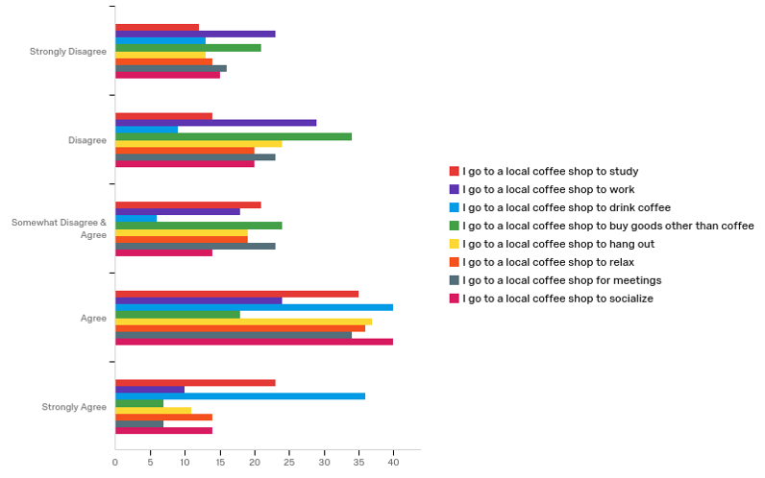
The reasons why people go to chain coffee shop:
The highest reason which people strongly disagree for going to chain coffee shop is to work.
The highest reasons which people disagree for going to chain coffee shop is to work and socialize.
The highest reasons which people somewhat disagree or agree for going to chain coffee shop is for meeting and to work.
The highest reason which people agree for going to chain coffee shop is to drink coffee.
The highest reason which people strongly agree to chain coffee shop is to drink coffee.

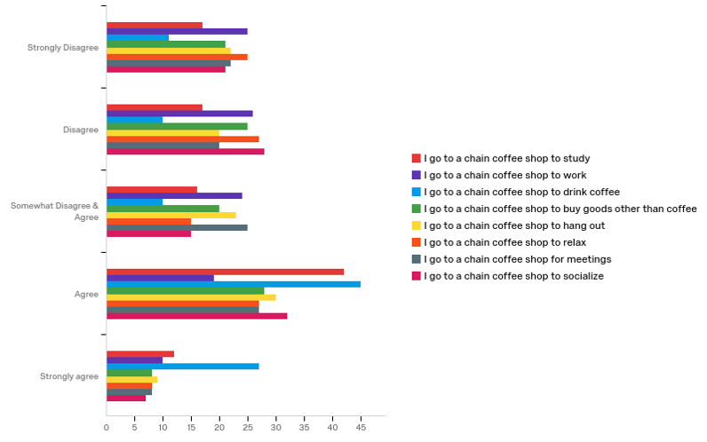

Satisfaction factors of customers of Crimson & Whipped Cream：
Factor | Extremely Unsatisfied | Unsatisfied | Somewhat Unsatisfied & Satisfied | Satisfied | Extremely satisfied | Total
Cozy Atmosphere | n: 0  0.00% | n: 2  7.69% | n: 6  23.08% | n: 14  53.85% | n: 4  15.38% | n: 26  100%
Friendly Staff | n: 0  0.00% | n: 1  3.85% | n: 1  3.85% | n: 16  61.54% | n: 8  30.77% | n: 26  100%
Taste of Coffee | n: 0  0.00% | n: 1  3.85% | n: 7  26.92% | n: 12  46.15% | n: 6  23.08% | n: 26  100%
Location | n: 1  4.00% | n: 1  4.00% | n: 7  28.00% | n: 13  52.00% | n: 3  12.00% | n: 25  100%
Convenience | n: 0  0.00% | n: 0  0.00% | n: 7  26.92% | n: 14  53.85% | n: 5  19.23% | n:26  100%
Price of Coffee | n: 2  7.69% | n: 4  15.38% | n: 5  19.23% | n: 14  53.85% | n: 1  3.85% | n: 26  100%
Variety of  Drinking Options | n: 0  0.00% | n: 3  11.54% | n: 5  19.23% | n: 15  57.69% | n: 3  11.54% | n: 26  100%
Taste of  Baked Goods | n: 0  0.00% | n: 2  7.69% | n: 6  23.08% | n: 12  46.15% | n: 6  23.08% | n: 26  100%
Price of  Baked Goods | n: 0  0.00% | n: 8  30.77% | n: 4  15.38% | n: 11  42.31% | n: 3  11.54% | n: 26  100%
Variety of  Baked Goods | n: 0  0.00% | n: 1  4.00% | n: 9  36.00% | n: 13  52.00% | n: 2  8.00% | n: 25  100%

RQ 2: What factors are affecting the customer’s decision to go to Crimson and Whipped Cream?
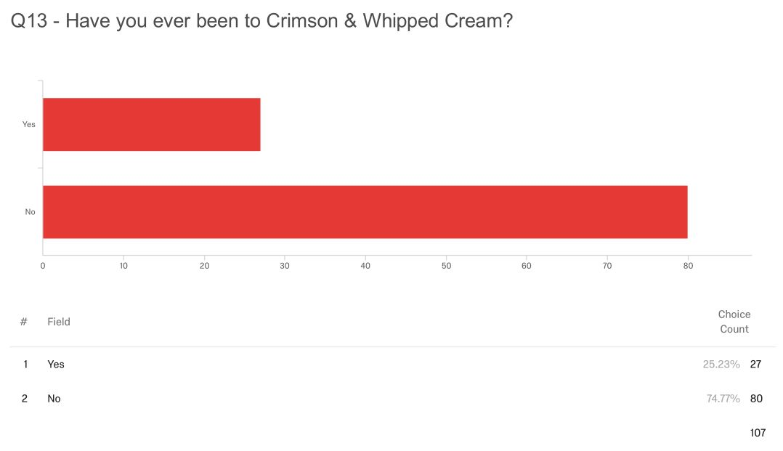
Q15 - If you have visited Crimson & Whipped Cream before, how did you hear about it? (You can choose more than one)

# | Answer | % | Count
1 | Advertisement | 3.23% | 1
2 | Social Media | 9.68% | 3
3 | From a Friend | 45.16% | 14
4 | From a Classmate | 6.45% | 2
5 | From a Parent | 3.23% | 1
6 | From a Colleague | 0.00% | 0
7 | On-Campus Promotion | 12.90% | 4
8 | Other | 19.35% | 6
 | Total | 100% | 31

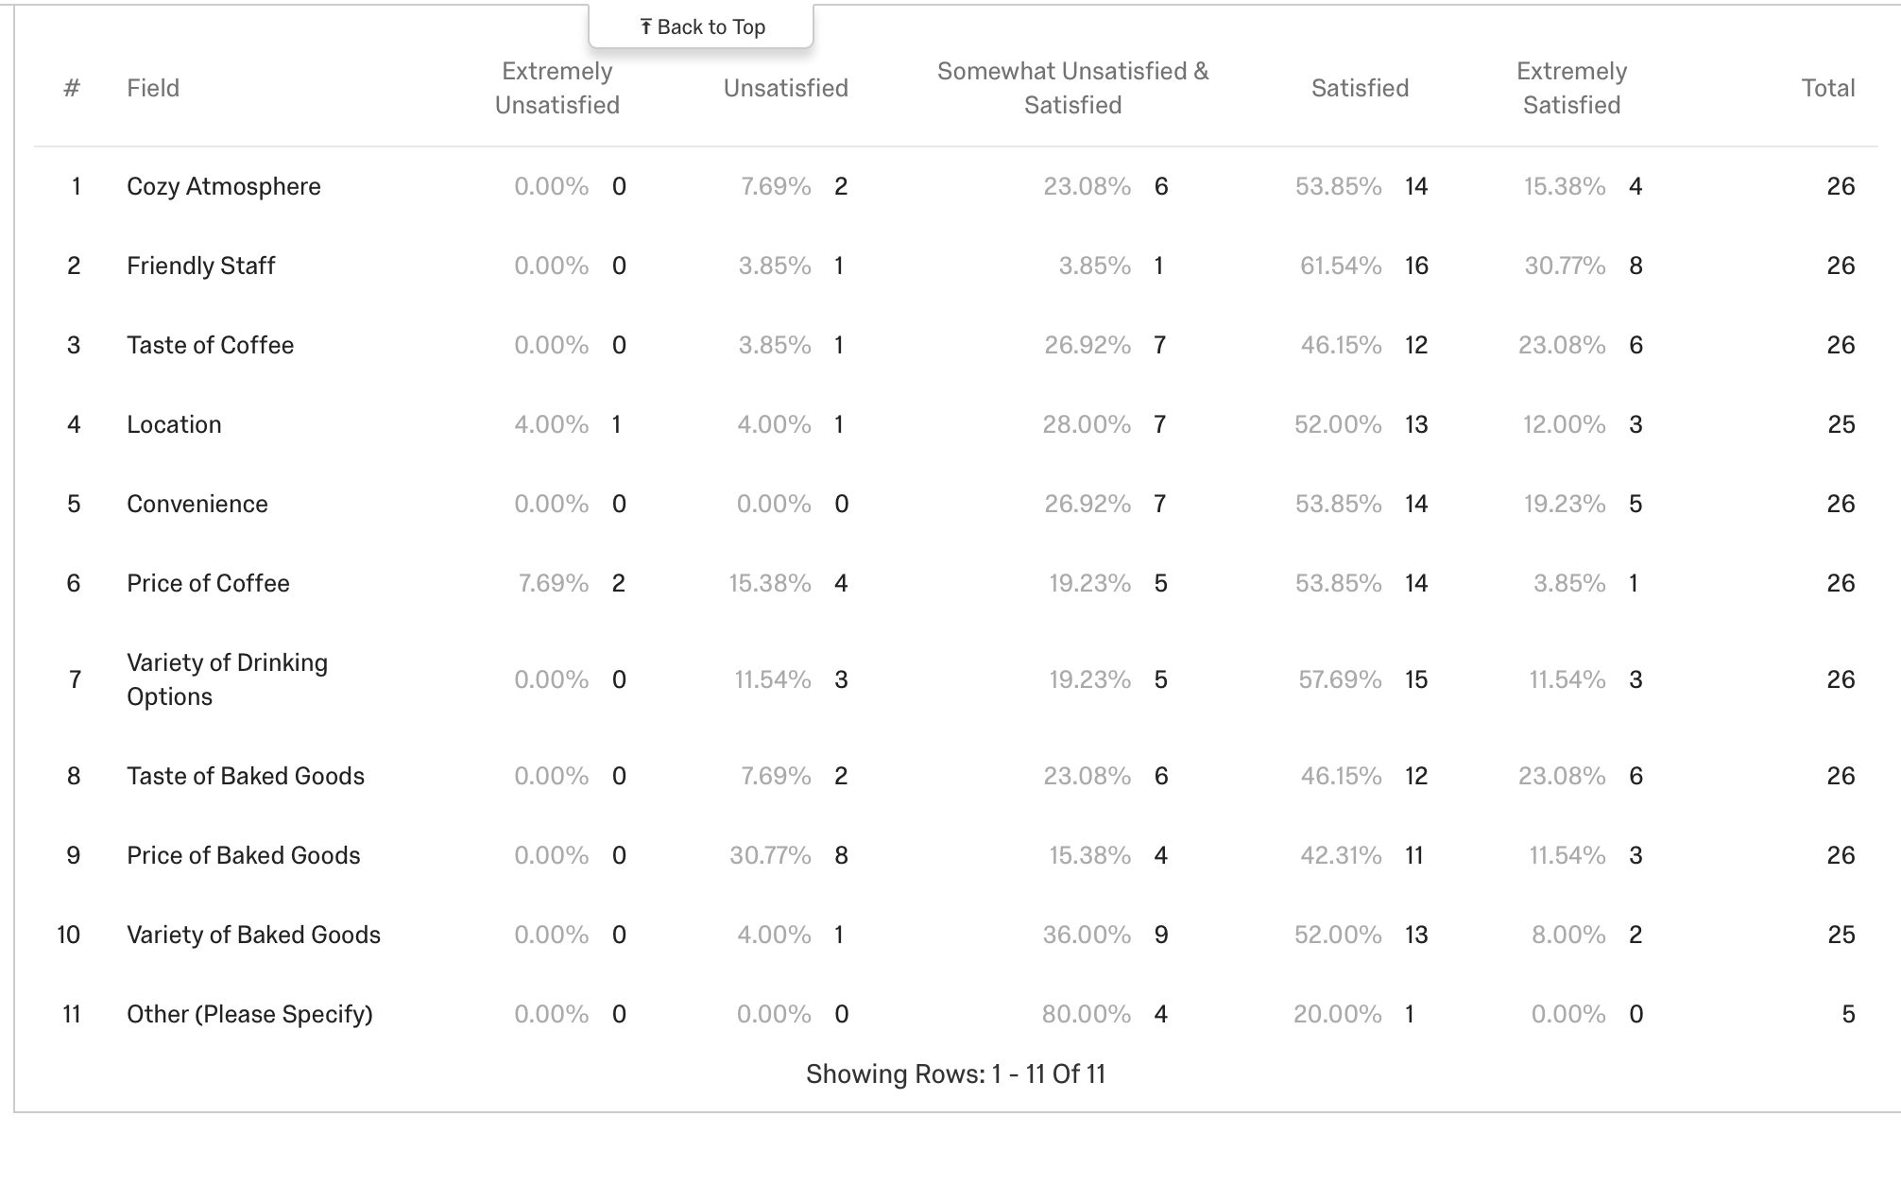

Focus Group Results and Findings
The participants of the focus groups were all undergraduate students at OU that consisted of male and female participants. The only difference between the two focus groups were the number of males and females in each group. The first group with six participants consisted of all females. The second group, consisting of four members, had three males and one female. This was not something that was planned by the researchers but it was interesting to see that the focus groups ended up being uneven. This caused the researchers to notice some differences between the two groups. The researchers noticed that in the first focus group, the females were not likely to speak over one another. When a question was asked, they would each look around at each other and wait for the first person to answer. It seemed as though none of them wanted to be the first to speak up, for whatever reason. The focus group consisting of all females was also more likely to agree with one another instead of responding in their own words. It was more common among the females to either reply “yes” in agreeance or just nod their head when another participant made a comment that they agreed with. That is something that was not common among the second focus group that consisted of three males and one female. None of them were afraid to be the first to speak up, causing many of them to speak at the same time. Even the female in the focus group was more likely to voice her own opinion instead of just nodding her head in agreeance. The mannerisms also differed from the first to the second focus group. One of the males was standing up, while the rest were leaned over the table, taking up far more space than needed. The females in the first focus group all sat with their hands in their laps, unless they were grabbing their phones.
It was a common occurence through both focus groups for participants to glance at their phones. Some of them seemed to be checking the time, while others would grab their phones to send a quick text. They all had them close by and on the tables, though the first focus group consisting of all females was more likely to pick up their phones to respond to a text. The researchers do not know why this was more common among the females, but can assume that maybe they were not as comfortable with each other and were using their phones as a way to remain in their comfort zones. The focus group that was male heavy did not check their phones as frequently, but they were also more willing to converse with one another about their thoughts and opinions. These two ideas could correlate, or maybe the females in the first focus group just had messages they had to respond to. This comes with the age demographic and the influence technology has today. While noticing this during the focus groups, it made the researchers think of the importance of reaching the target audience. It is evident that students are surrounded by technology, so encouraging the client to increase advertisements on social media outlets will benefit them.
The participants were also consistently bouncing off each other’s ideas and answers to create a small discussion with each other. The researchers were there to start the discussion but as each question was asked, it was noticed that they talked to each other and agreed with what some had to say. There were never any disagreeances that occurred, or even if a participant did not agree with what another was saying, he or she did not voice their opinion. Elements of in-depth responses and discussions were taken in notes and observations throughout the focus groups. The researchers think that the focus groups were able to give a more detailed explanation for what the client should look for in top competitors and how they can create some of those positive qualities for themself. The focus group successfully reached saturation that gave the important information that location, products and knowledge about the company are deciding factors.
Discussion and Importance of Findings
Survey Discussion and Importance of Findings
It is that see people strongly disagree to work in both local and chain coffee shops. On the other hand, people strongly agree to drink coffee in both local and chain coffee shop. Whatever local coffee shop or chain coffee shop, both of them have same highest reasons which people strongly disagree and agree. It shows that people have similar attitude and behavior for both local and chain coffee shop. It shows that coffee is the key reason why people go to local and chain coffee shop. On the contrary, people do not like to work at both local and chain coffee shop, so our client does not need to set a special style or environment in coffee shop for office work of customers.
Friendly staff is the factor which the most customers feel Satisfied, 61.54% of customers who have gone to Crimson & Whipped Cream think friendly staff attract them to go to Crimson & Whipped Cream. We think our client should consist this advantage, it is one of the unique selling propositions of Crimson & Whipped Cream. Friendly staff will bring a cordial feeling to people, it is much different from big or chain coffee shop. On the other hand, 30.77 percent of customers feel unsatisfied about price of baked goods, logically, we defined the price of baked goods is too high for people. This is also a disadvantage of Crimson & Whipped Cream, so we suggest that our client may reduce its price of baked goods to improve satisfaction of old customers, and it will also increase customer flow if the price of baked goods can be lower than before.
The researchers show through this survey the the important aspects of Crimson & Whipped Cream that consumers have noticed. Friendly staff and price is important when it comes to choosing this coffee shop/bakery over a chain. From the results above you can see that there is a variety of aspects that were given positive feedback from the audience but that the main characteristic they are looking for is a friendly staff. Research question 2 can show the client what consumers are looking for in a coffee shop and the statistics show that.

Focus Groups Discussion and Importance of Findings
Theme 1: OU undergraduate students stated they have never been to Crimson & Whipped Cream because they have never seen it advertised. They thought they would be more inclined to go if they saw social media advertisements or heard more about the coffee shop from friends.
Theme 2: OU undergraduate students believe quality of coffee is the most important characteristic when choosing which coffee shop to go to.
Theme 3: OU undergraduate students stated they frequent Starbucks the most because it is the most widely known coffee shop and they know what to order every time.
It is important to create a strategy for the client depending on these themes that the researchers noticed in their focus groups. Theme 1 shows that Crimson & Whipped Cream does not have enough popularity among OU undergraduate students. This is one of the client’s largest issues which directly affects their customer flow. The researcher’s report of their survey also shows that only 25.23 percent of OU undergraduate students have ever been to Crimson & Whipped Cream before. This will affect their business especially since it is located in a college town and students are its’ primary customers. To increase the client’s brand awareness, it is necessary to increase the knowledge of OU undergraduates about Crimson & Whipped Cream. Theme 1 also reveals that the lack of advertising is one of the reasons why OU undergraduate students do not know about the shop, and they stated that social media advertisements would attract them to go to Crimson & Whipped Cream. Theme 2 is about the importance of the quality of coffee. It can be difficult to prove to customers that Crimson & Whipped Cream has quality coffee, but it can be achieved if the business can find a way to allow more students to try the product. Lastly, theme 3 reveals that OU undergraduate students favor Starbucks over any other coffee shops solely because Starbucks is widely known and their orders are safe and known.
Strategic Recommendations
Based on the research conducted, it is evident through the qualitative data that many students have never visited Crimson & Whipped Cream because it has never been advertised. The study population stated that they would be more inclined to go if they saw social media advertisements or heard more about the coffee shop from friends. Even out of the students that had visited the client she said it had only been once. Ryan (Appendix 5) commented that he would be more likely to visit a coffee shop or bakery if they advertised specialty products. These aspects given from the target audience of Crimson & Whipped Cream show that the improvement a more known brand image would have a positive impact on the company success. Although many of the participants believed that advertising did not affect where they frequented and did not think that an increase in advertising would persuade them to visit Crimson & Whipped Cream, if the client can establish a platform to create for themselves then they will be able to form their own way of building their brand name to minimize the competition.
Another platform that could be used is partnerships. By utilizing the known organizations around campus, the client could take part in a sponsorship that would serve as brand awareness. This platform would be a simple form of advertising that will show Crimson & Whipped Cream as an involved company. This recommendation also shows the importance of local organization success. Due to the client being local, partnering with another local organization sticks to the original focus the client has established. It would create a positive brand awareness impact while also creating a solid organization relationship.
Limitations
Throughout the semester, the researchers faced a few limitations, some that they were prepared for and some that they had not seen coming. The first limitation they faced was in their ability to access an entire list of undergraduate students at the University of Oklahoma. The researchers ran into this issue before they sent out their surveys and conducted their focus groups. They used convenience sampling since they were unable to gain access to students who they did not know. If they would have been able to gain access to this complete list of students then they might have used a different form of sampling. The second limitation that the researchers faced was that not every respondent who took their survey was an OU undergraduate student. Though they began their survey with a preliminary question that asked respondents to only complete it if they were undergraduate students at OU, they still had respondents complete the survey who are not students. This led to the researchers having to use only a fraction of their total data. Out of the total survey responses, only 107 respondents were students at the University of Oklahoma. The third limitation they faced, and quite possibly the most difficult, was that many survey respondents and focus group participants had never actually been to Crimson & Whipped Cream. This made it extremely difficult for the researchers to understand what Crimson & Whipped Cream could possibly do to improve. From the 107 survey respondents who were OU undergraduate students, only 27 of them have previously visited Crimson & Whipped Cream. From both of the focus groups, only one person out of ten had actually visited Crimson & Whipped Cream prior to the focus group. This limitation made it more difficult for the researchers to answer their second research question, so many of their focus group results backed up the first research question.
The researchers have created some recommendations for future research based off of their experience from the semester. Their first recommendation is to have the survey available to students for a longer period of time. Due to the researchers having due dates for their assignments, they faced the problem of not getting to expand the length they had their survey open to the public. Having it available for a longer period of time will allow for the opportunity for more students to complete the survey. Their second recommendation is to make their study population more specific. This will allow for the data results to be more in-depth. This also allows for the researchers to truly understand their study population. It would have been much easier for them to target a smaller audience of people. The researchers’ third recommendation would be to have specific tailor-made focus groups for different topics. They think it would be beneficial to have a larger quantity of focus groups that focused on different topics. For future research, they recommend to have a multitude of focus groups with different topics such as a focus group about Crimson’s competitors or one solely about Crimson & Whipped Cream with previous customers.

References
Aasheim, C. (2017). Where to Find the Best Desserts in Norman, Oklahoma. Retrieved February 15, 2018, from https://spoonuniversity.com/place/where-to-find-the-best-desserts-in-norman-oklahoma
Abbott, S. (2017). The 9 Best Dessert Places In Norman, Oklahoma. Retrieved February 15, 2018, from https://www.theodysseyonline.com/9-dessert-places-norman-oklahoma
Amadeo, K. (2018). US economic outlook: for 2018 and beyond. The Balance. Retrieved from https://www.thebalance.com/us-economic-outlook-3305669
Harith, Z. (2013). Coffee packaging: Consumer perception on appearance, branding and pricing. doi:10.3897/bdj.4.e7720.figure2f
Jackson, J. (2006). OU students complain about lack of parking. News Ok. Retrieved from http://newsok.com/article/1832726
Ray, L. (n.d.). Seven external factors of business. Retrieved from http://smallbusiness.chron.com/seven-external-factors-business-21960.html
Roper, M. (2017). Best of Norman coffee: Local bakery features vegan cookies, cozy atmosphere. OU Daily. Retrieved February 14, 2017, from http://www.oudaily.com
Sherman, F. (n.d.). What are internal & external environmental factors that affect business? Retrieved from http://smallbusiness.chron.com/internal-external-environmental-factors-affect- business-69474.html
Sullivan, H. (n.d.). 5 Tips to Leverage Social Media and Content Marketing as PR Tools.
Retrieved February 14, 2018, from https://www.prsa.org/resource-library/5-tips-leverage-
social-media-content-marketing-pr-tools/
Terkan, R. (2014). Importance of creative advertising and marketing according to university
students’ perspective. International Review of Management and Marketing,4(3), 239-
246. Doi:2146-4405.
Van Loo, E. J. (2015). Sustainability labels on coffee: Consumer preferences, willingness-to-pay and visual attention to attributes. doi:10.1107/s0108768104030617/bs5012sup1.cif

Appendices
Appendix 1: Survey
Crimson and Whipped Cream:
The Factors College Students Bring to the Success of A Coffee Shop
Thank you for agreeing to participate in this survey. You are invited to join the OU community to share their prior knowledge and opinions of Crimson & Whipped Cream. The results of this survey will help us better understand what draws customers to Crimson & Whipped Cream and what keeps people from frequently visiting the shop on Campus Corner. You are asked to answer each question to the best of your ability, based on the knowledge that you have prior to this survey. It will take about 10 minutes to complete this survey. Your participation in this is anonymous, the survey is voluntary and you are able to stop at any time. The results of this study will inform Crimson & Whipped Cream about why people at OU are or are not visiting their shop. Those results will then help them better tailor their shop to the students, faculty and staff of OU.
SURVEY
1. Are you an undergraduate student at the University of Oklahoma?
Yes____ No____
2. Have you ever been to Crimson & Whipped Cream?
Yes____ No____
a. If yes, how was your experience? _____________________________
3. How likely are you to bring your business to a local coffee shop?
(1 Not Likely - 5 Very Likely)
1 2 3 4 5
4. How likely are you to bring your business to a chain coffee shop (i.e. Starbucks) over a local coffee shop?
(1 Not Likely - 5 Very Likely)
1 2 3 4 5
5. How often do you drink coffee?
- Daily
- Weekly
- Monthly
- Occasionally
- Never
6. What time of the day do you drink coffee? (You can choose more than one)
- Morning
- Noon
- Afternoon
- Evening
- Midnight
- I don’t drink coffee
7. How many times per week do you go to a coffee shop that you like?
- Never
- 1-2 / week
- 3-5 /week
- Every day
8. For what reasons do you go to a coffee shop that you like? (You can choose more than one)
- Studying
- Business/Work
- Coffee/Tea
- Baked goods
- Hang out/Relax
- Other ________________
9. How important is consuming locally grown coffee to you?
(1 Not Important - 5 Very Important)
1 2 3 4 5
10. How important is consuming homemade/family-based baked goods to you?
(1 Not Important - 5 Very Important)
1 2 3 4 5
*Questions 11-17 are based on how IMPORTANT the following qualities are to you when choosing a coffee shop*
11. “I always go to my favorite coffee shop because it is the closest to my place...”
(1 Strongly Disagree - 5 Strongly Agree)
1 2 3 4 5
12. “I always go to my favorite coffee shop because they have the best atmosphere...”
(1 Strongly Disagree - 5 Strongly Agree)
1 2 3 4 5
13. “I always go to my favorite coffee shop because they have the most reasonable prices…”
(1 Strongly Disagree - 5 Strongly Agree)
1 2 3 4 5
14. “I always go to my favorite coffee shop because they have the broadest selection of coffee, tea, and baked goods…”
(1 Strongly Disagree - 5 Strongly Agree)
1 2 3 4 5
15. “I always go to my favorite coffee shop because they have the best quality of coffee…”
(1 Strongly Disagree - 5 Strongly Agree)
1 2 3 4 5
16. “I always go to my favorite coffee shop because they have Wi-Fi and other services to assist my studying/work…”
(1 Strongly Disagree - 5 Strongly Agree)
1 2 3 4 5
17. “I always go to my favorite coffee shop because they have the friendliest baristas compared to other coffee shops…”
(1 Strongly Disagree - 5 Strongly Agree)
1 2 3 4 5
18. You are: Female Male Other Prefer not to answer
19. What year are you in school at OU?
- Freshman
- Sophomore
- Junior
- Senior
- Other___________
20. How old are you? ___________
21. How did you hear about Crimson and Whipped Cream?
______________________________________
Thank you for filling out this survey!
Thank you for participating in our study! If you would like to receive an electronic summary of the survey results, please send an email to makenzie.dean@ou.edu. Your responses will help inform Crimson & Whipped Cream about what people look for in a coffee shop and bakery and will help us learn more about what we can do to bring in more customers.
Appendix 2: Focus Group Protocol
- How often do you visit coffee shops or bakeries in Norman?
- Would you rather go to a chain coffee shop or a local coffee shop? And, why?
- What coffee shops or bakeries have you visited, if any, on Campus Corner?
- Why do you visit those specific coffee shops or bakeries?
- Does location of the coffee shop influence your decision of which one to go to?
- What aspects are you looking for in a coffee shop? Such as price, location, wifi?
- Have you ever been to Crimson & Whipped Cream? (all said no) Why not?
- When you first think about coffee shops or bakeries, what is the first impression or adjective that comes to your mind?
- What do you think of when you think of coffee shops? Like what’s the first word that you think of?
- What do you mainly order from there when you go to a coffee shop? Baked goods, coffee, tea?
- How does the quality of products influence where you shop? For example, if it’s locally grown or homemade baked goods? Organic?
- How does advertising affect where you purchase your coffee and baked goods?
- So do you think if you would have heard more about Crimson & Whipped Cream, if it was advertised, that you would go there?
- Why do you think you haven’t heard of Crimson and Whipped Cream?
- Do you think if you would have heard more about Crimson & Whipped Cream, if it was advertised, that you would go there? Why?

Appendix 3: Focus Group Transcription
Focus Group #1

Researcher: How often do you visit coffee shops or bakeries in Norman?
- Kayla: Not very often
- Allie: Yeah no, not often
- Emery: I go to Starbucks a lot
- Brooklyn: Yeah, Starbucks
- Hannah: I never do
- Katey: I was going to say Starbucks, but there is Gray Owl that I will occasionally go to, not a lot though

Researcher: Would you rather go to a chain coffee shop or a local coffee shop? And, why?
- Allie: I just go to Starbucks because I think of it first
- Brooklyn: It’s more convenient too
- Emery: Yeah

Researcher: What coffee shops or bakeries have you visited, if any, on Campus Corner?
- Allie: I’ve been to Crimson & Cream once forever ago
- Hannah: Starbucks, once
- Emery: I went to that Apple Tree place, does that count?
- Kayla: That’s a great place

Researcher: Why do you visit those specific coffee shops or bakeries?
- Hannah: The ones on Campus Corner? … I just walked past it once
- Emery: The free wifi
- Katey: I went to Stella Nova once because it was hyped up and I was like ‘Oh I kind of want to go....That place is really good
- Brooklyn: I like that place
- Katey: Yeah, it’s really good

Researcher: Does location of the coffee shop influence your decision of which one to go to?
- Kayla: Yes
- Allie: Yeah
- Emery: Sometimes I don’t want to see people so I go to the farther Starbucks

Researcher: What aspects are you looking for in a coffee shop? Like price, location, wifi?
- Allie: Definitely wifi if I am doing homework
- Kayla: Not too loud
- Allie: Not too crowded, yeah
- Brooklyn: Not too expensive
- Multiple: Yeah
- Hannah: There has to be seating
- Emery: If they have like little snacks there

Researcher: Have you ever been to Crimson & Whipped Cream?
- Allie: Once
- Kayla: No
- Hannah: No
- Brooklyn: No
- Katey: No

Researcher: Why not?
- Katey: I have personally never heard of it I’m going to be honest
- Emery: Yeah
- Kayla: Same
- Hannah: I’ve never heard of it

Researcher: When you first think about coffee shops or bakeries, what is the first impression or adjective that comes to your mind?
- Hannah: Calm
Researcher: Like what do you think of when you think of coffee shops? Like what’s the first word that you think of?
- Emery: Studying
- Allie: Yeah studying
- Brooklyn: Coffee

Researcher: What do you mainly order from there when you go to a coffee shop? Like baked goods, coffee, tea?
- Kayla: Tea
- Hannah: Tea
- Allie: Iced coffee
- Emery: Coffee
- Brooklyn: Hot drinks

Researcher: How does the quality of products influence where you shop? Like if its locally grown or homemade baked goods? Organic?
- Kayla: If it’s good I’ll go there
- Multiple: Yeah
- Hannah: I feel like price is more important than organically grown
- Emery: I don’t care about that stuff

Researcher: How does advertising affect where you purchase your coffee and baked goods?
- Allie: I mean if you hear from other people that it’s good then you go there
- Brooklyn: Yeah

Focus Group #2

Researcher: How often do you visit coffee shops or bakeries in Norman?
- Casey: Once a week
- Ryan: Once a week
- Luke: Hardly ever
- Kyle: I’d say once a week, I drink coffee a lot, but mostly at home

Researcher: Would you rather go to a chain coffee shop or a local coffee shop?
- Casey: Chain coffee shop
- Ryan: Starbucks
- Luke: Chain
- Kyle: A chain one because I know what I like
And, why?
- Kyle: I know that they’ll have what I like
- Casey: I get the same thing every time
- Luke: You don’t know what you’re getting when you go to a local one, especially one you've never been to before
- Ryan: It’s a hit or miss

Researcher: What coffee shops or bakeries have you visited, if any, on Campus Corner?
- Kyle: I go to Starbucks quite a bit
- Luke: I’ve been to Insomnia...Oh you said like bakery, it’s a bakery

Researcher: Why do you visit those specific coffee shops or bakeries on Campus Corner?
- Casey: Because Starbucks is the best
- Ryan: Starbucks is my coffee
- Luke: I literally just went with a friend one time
- Kyle: It’s always good (Starbucks)

Researcher: Does location of the coffee shop influence your decision of which one to go to? Why or why not?
- Casey: No
- Luke: Yeah, it could
- Kyle: I’d say location can but it’s more about quality...like if it’s really good coffee then I’ll go there no matter what even if it’s more of a drive
- Ryan: Yeah, if it’s good coffee I’ll go

Researcher: What aspects are you looking for in a coffee shop? Like price, location, atmosphere, wifi, that kind of thing…
- Kyle: Definitely coffee
- Casey: I just only go to Starbucks. I don’t care. Starbucks could be like $8 for a cup of coffee and I would buy it
- Luke: Quality of coffee because usually the times I go, I don’t stay there, I just get my stuff and leave. I don’t sit around
- Ryan: Wifi...Wifi’s good. It’s a good study spot

Researcher: Have you ever been to Crimson & Whipped Cream?
- Luke: No
- Casey: No
- Kyle: No
- Ryan: No
Researcher: For those of you who said no, why have you not been there?
- Luke: I’ve never heard of it
- Casey: I think I have only seen it twice
- Kyle: Yeah, this is my first time hearing about it
Researcher: Why do you think you haven’t heard of it?
- Casey: It’s kind of in the back of Campus Corner and you can’t really see it
- Ryan: It’s not a Starbucks
- Kyle: Nobody tells me about it

Researcher: When you first think about coffee shops or bakeries, what is the first impression or adjective that comes to your mind?
- Kyle: Starbucks
- Casey: Starbucks
- Ryan: Coffee
- Kyle: Bakery
- Luke: Dunkin Donuts...No not Dunkin...Krispy Kreme….I’m thinking about the donuts. I don’t drink coffee very much

Researcher: What do you mainly order from there when you go to a coffee shop? Like baked goods, coffee, tea?
- Kyle: Coffee
- Ryan: Iced coffee
- Kyle: Caramel macchiato
- Casey: Iced chai tea latte
- Ryan: White chocolate mocha
- Luke: I like it black
- Kyle: Something with caramel or vanilla
- Casey: Pumpkin spice

Researcher: How does the quality of products influence where you shop? Like if its locally grown or homemade baked goods? Organic?
- Kyle: 11 out of 10
- Casey: 100%
- Luke: I am definitely a quality guy… I am willing to spend more money to get better products
- Casey: If it’s not good, I don’t want it
- Kyle: Quality over quantity

Researcher: How does advertising affect where you purchase your coffee and baked goods?
- Kyle: Not that much
- Casey: Not really at all
- Ryan: No
Researcher: So do you think if you would have heard more about Crimson & Whipped Cream, if it was advertised, that you would go there?
- Casey: Yeah, maybe, yeah
- Ryan: It depends
- Kyle: No because Starbucks is right next to it
- Casey: I would go there if I knew more about it
- Ryan: If they have like specialty products
Researcher: So like advertising does affect it?
- Kyle: Like if someone said like ‘hey they have a really cool macchiato’ then yeah but if I am driving and I see a Starbucks right there then I’m going to go

Appendix 4: Focus Group Notes
Focus Group #1: Notes
- All female
- Lots of responses included women agreeing with each other or nodding heads in agreeance with one another
- In Crimson & Whipped Cream
- Lots of distracting noise that caused participants to look around
- Did not seem comfortable with each other
- Most participants kept their hands in their laps
- Participants doing things to distract them while others spoke, like playing with their hair
- Spoke softly
Focus Group #2: Notes
- 3 males & 1 female
- In Crimson & Whipped Cream
- Seemed much more comfortable
- Talked over each other more than first focus group
- Never just nodded their head in agreeance, were always willing to each voice their own opinions
- Majority talked about how much they liked Starbucks (and other chains) over local coffee shops
- All spoke loudly, seeming as they were not afraid of giving their opinion
- One participant (male) was standing
- Other male participants leaning over the table

Appendix 5: Focus Group Pseudo Names
Focus Group #1

Pseudo Names | Characteristics
Kayla | - Does not frequent coffee shops  - Location influences decision  - Looking for quiet place  - Has never been to Crimson because has never heard of it  - Orders tea at coffee shops  - College female  - Casually dressed  - Checks watch for time constantly  - Looking around during questions
Allie | - Does not frequent coffee shops  - Usually thinks of Starbucks first  - Has been to Crimson once  - Location affects decision  - Looking for a coffee shop that isn’t crowded and that has wifi  - Studies at coffee shops  - Orders iced coffee  - More willing to visit a place if recommended by a friend  - Paid attention to questions  - Arms crossed  - College female
Emery | - Frequents Starbucks  - Would rather visit chain because of convenience  - First thought of Apple Tree Chocolate when asked about coffee shop or bakery on Campus Corner  - Looking for free wifi at a coffee shop  - Location doesn’t matter - Willing to drive to farther Starbucks if not interested in seeing people she knows  - Likes coffee shops with “little snacks”  - Has never been to Crimson, nor heard of it  - Studies at coffee shops  - Orders coffee  - Does not care about quality of products  - College female  - Friends with another participant
Brooklyn | - Visits Starbucks because of convenience  - Has been to Stella Nova in Norman and “likes it”  - Looking for a coffee shop that is not too expensive  - Has never been to Crimson  - Orders hot drinks at coffee shops  - Agrees that she is more likely to visit a place if recommended by a friend  - Made a comment after focus group that she wanted to go to Crimson after talking about it for so long
Hannah | - Does not frequently visit coffee shops or bakeries  - Has been to Starbucks on Campus Corner once and only went because she noticed it when she was walking by it  - Looking for a coffee shop with wide array of seating  - Has never been to Crimson & has never heard of it  - Wants a coffee shop to be a calm place  - Orders tea at coffee shops  - Thinks price plays a bigger factor than quality of products  - College female  - Keep playing with bracelets on arm  - Looked at people walking through door during focus group
Katey | - Frequently visits Starbucks  - Occasionally goes to Gray Owl  - Went to Stella Nova because of all the “hype” and liked it  - Has never been to Crimson & is not afraid to let researchers know that she has never heard of it  - College female  - Threw away a Starbucks coffee when coming into focus group

Focus Group #2

Pseudo Names | Characteristics
Casey | - Visits coffee shops or bakeries once a week  - Prefers chain because she orders the same thing every time  - Location does not influence her  - Prefers Starbucks over all other coffee shops  - Would be willing to even pay more, just at Starbucks  - Has never been to Crimson, but recalls that she has seen it a couple of times before - Thinks this is due to location of coffee shop  - Orders iced chai tea latte or something pumpkin spice at coffee shops  - Quality of products is a huge factor  - Says advertising does not affect decisions, but would be more willing to visit Crimson if she knew more about it  - College female
Ryan | - Visits coffee shops or bakeries once a week  - Prefers Starbucks because local coffee shops are a “hit or miss”  - Willing to travel farther for coffee shop if it is good coffee  - Looking for coffee shop with wifi  - Has never been to Crimson and thinks he has not heard of it because it is “not a Starbucks”  - Orders iced coffee or a white chocolate mocha at coffee shops  - Does not think advertising affects decisions, unless it was a coffee shop advertising specialty products  - College male  - Quietest  - Responded more with head nods and body language than with words
Luke | - Hardly ever visits coffee shops or bakeries  - Prefers chain because he “does not know what he is getting with a local coffee shop”  - First thought of Insomnia cookies when asked about coffee shops or bakeries on Campus Corner  - Went to a coffee shop once before because a friend took him  - Location influences decision  - Atmosphere of coffee shop does not matter because he takes his coffee to go  - Has never been to Crimson nor has he ever heard of it  - Orders coffee black  - More willing to pay more for quality products  - College male  - Was standing during focus group & leaning on table  - Very open to speaking with everyone, during interview and outside of interview
Kyle | - Visits coffee shops or bakeries once a week  - Prefers coffee from home  - Prefers chain over local because he knows what he likes  - Has visited Starbucks on Campus Corner  - Thinks location does affect decision, but that quality trumps all because he is willing to travel farther for more quality products  - Taste/Quality of coffee a great factor when choosing coffee shop  - Has never been to Crimson nor has he ever heard about it  - Orders coffee, caramel macchiato or something with caramel and vanilla at coffee shops  - Has a quality over quantity mindset when it comes to products  - Does not think advertising plays a huge role in decision-making  - College male  - Gave most in-depth answers

Appendix 6: Consent Forms
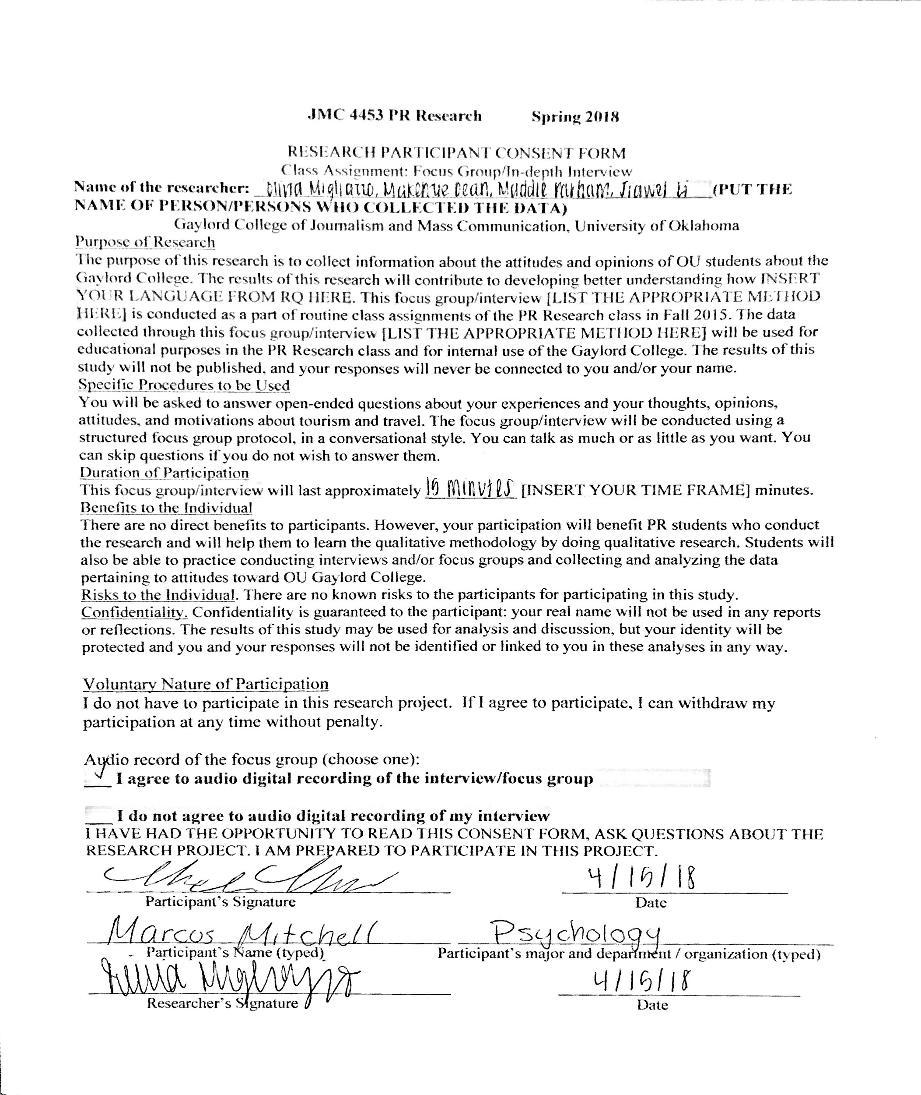

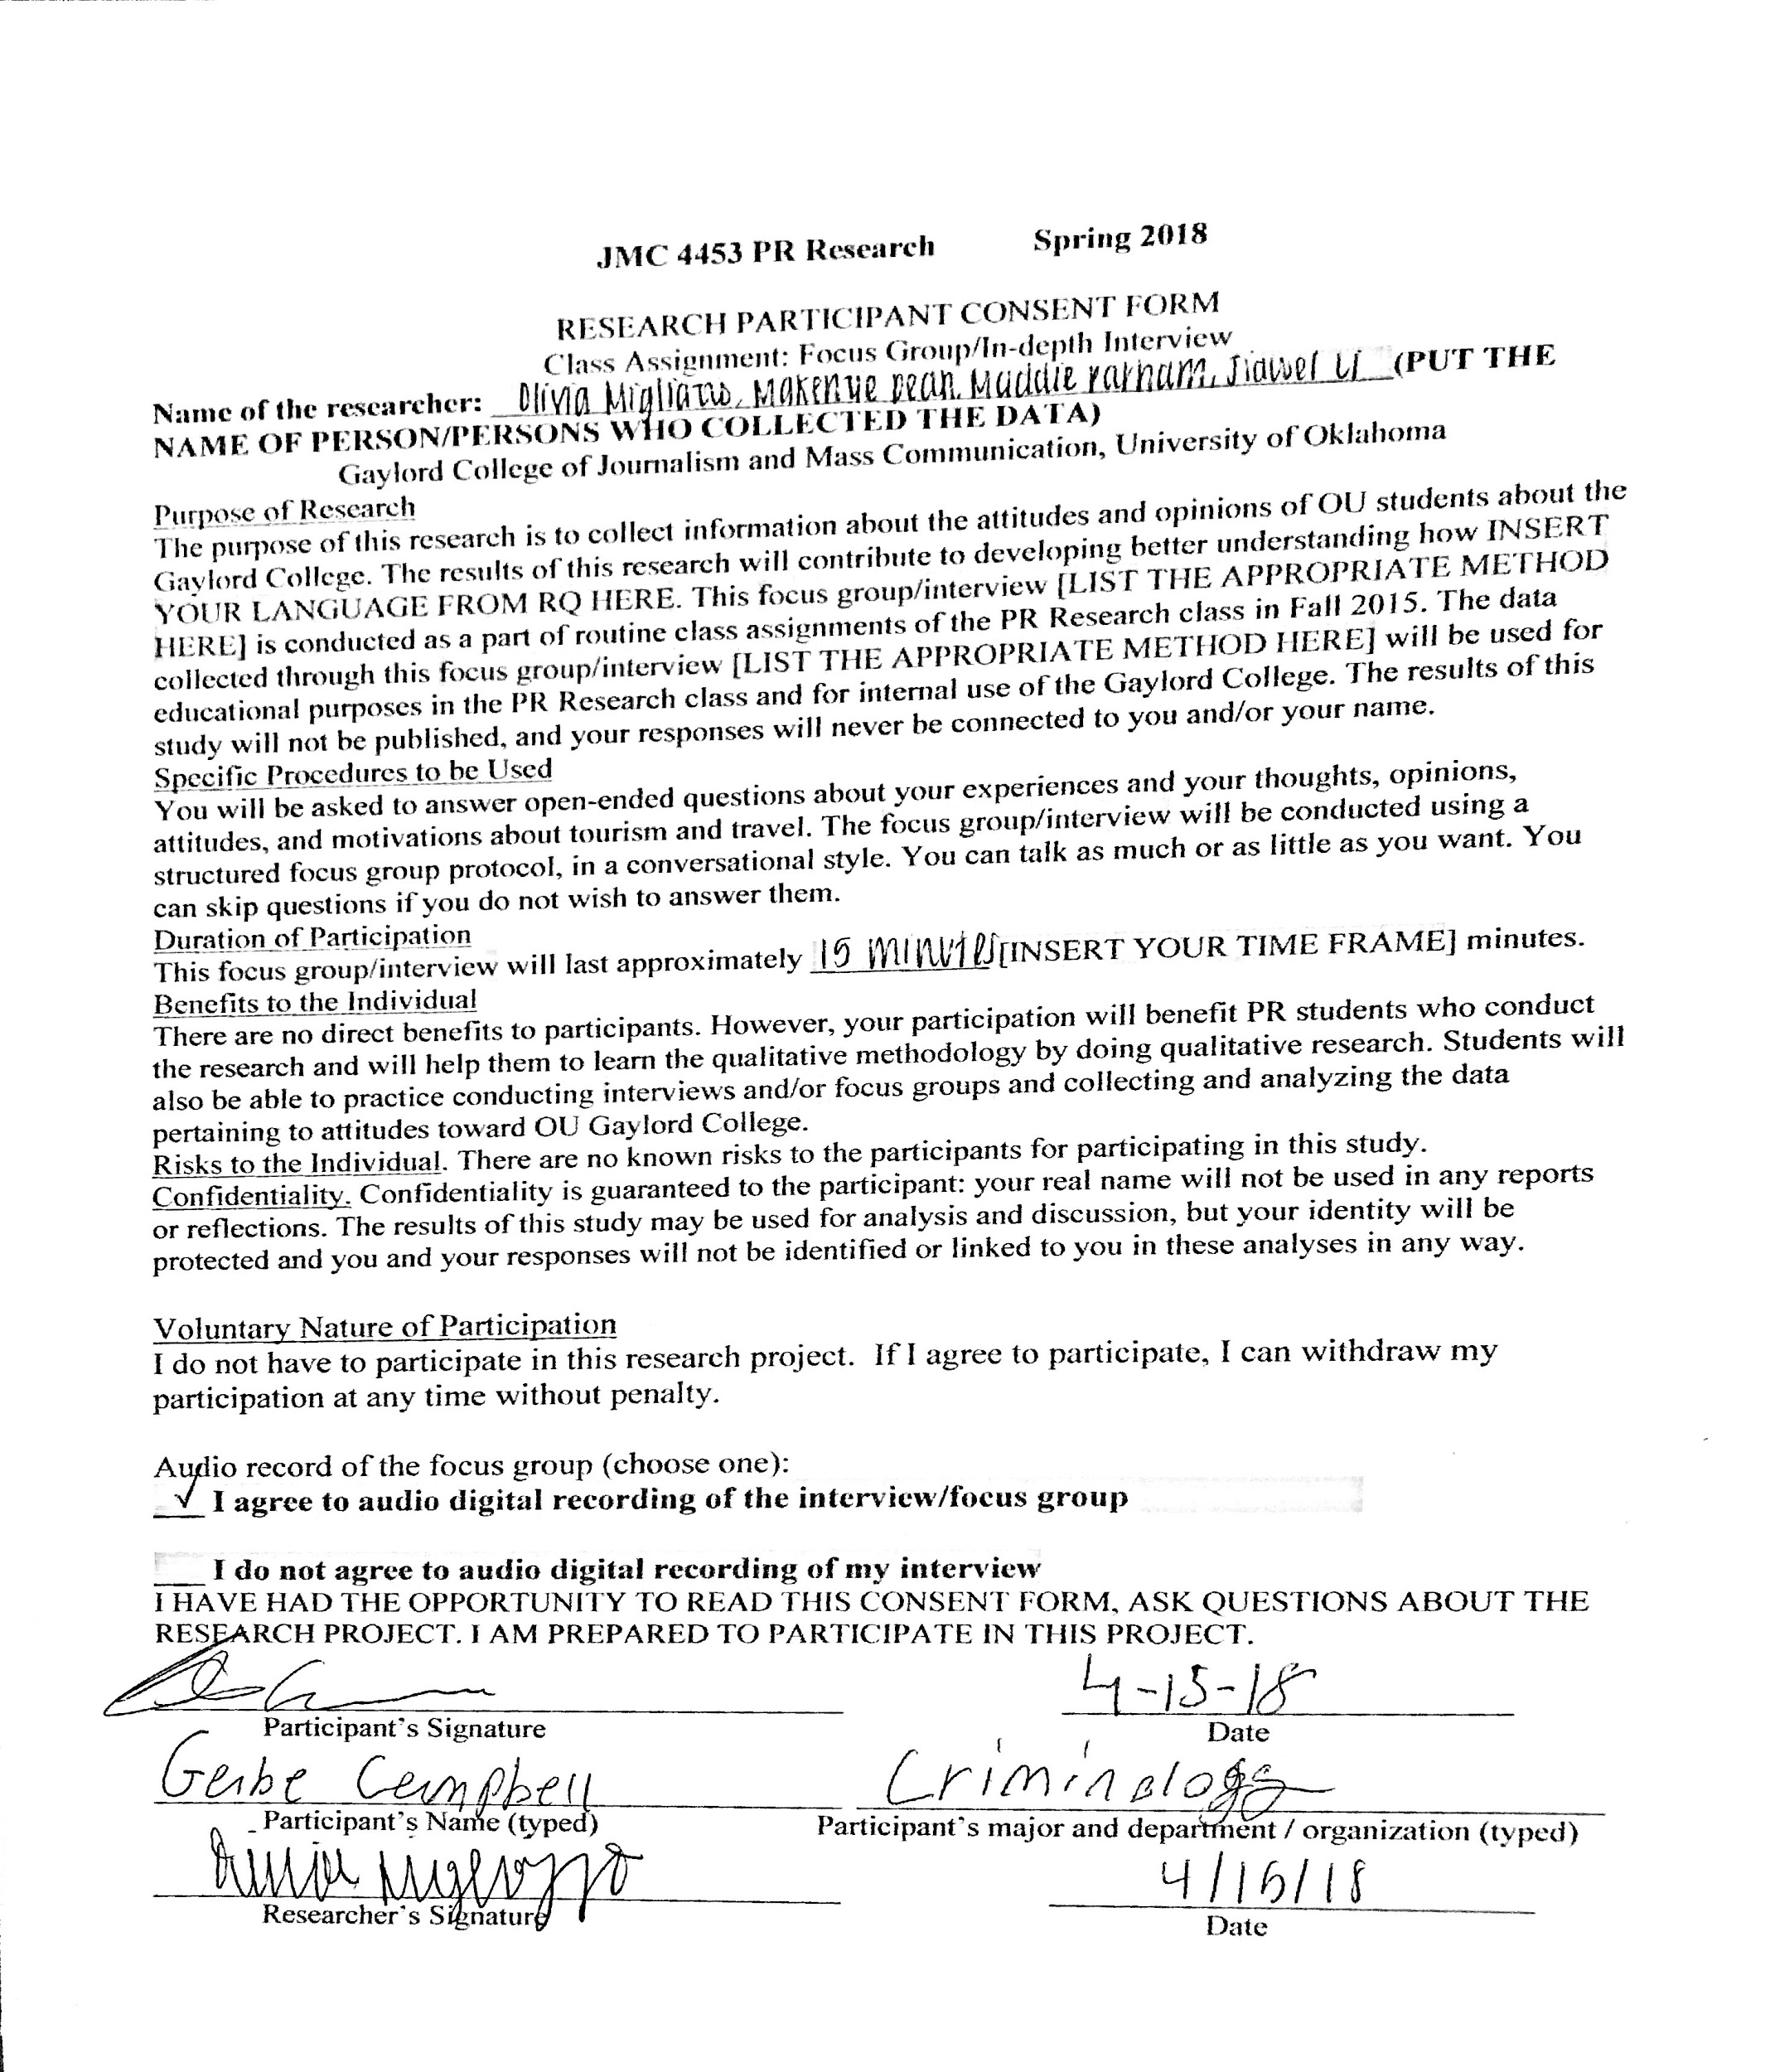
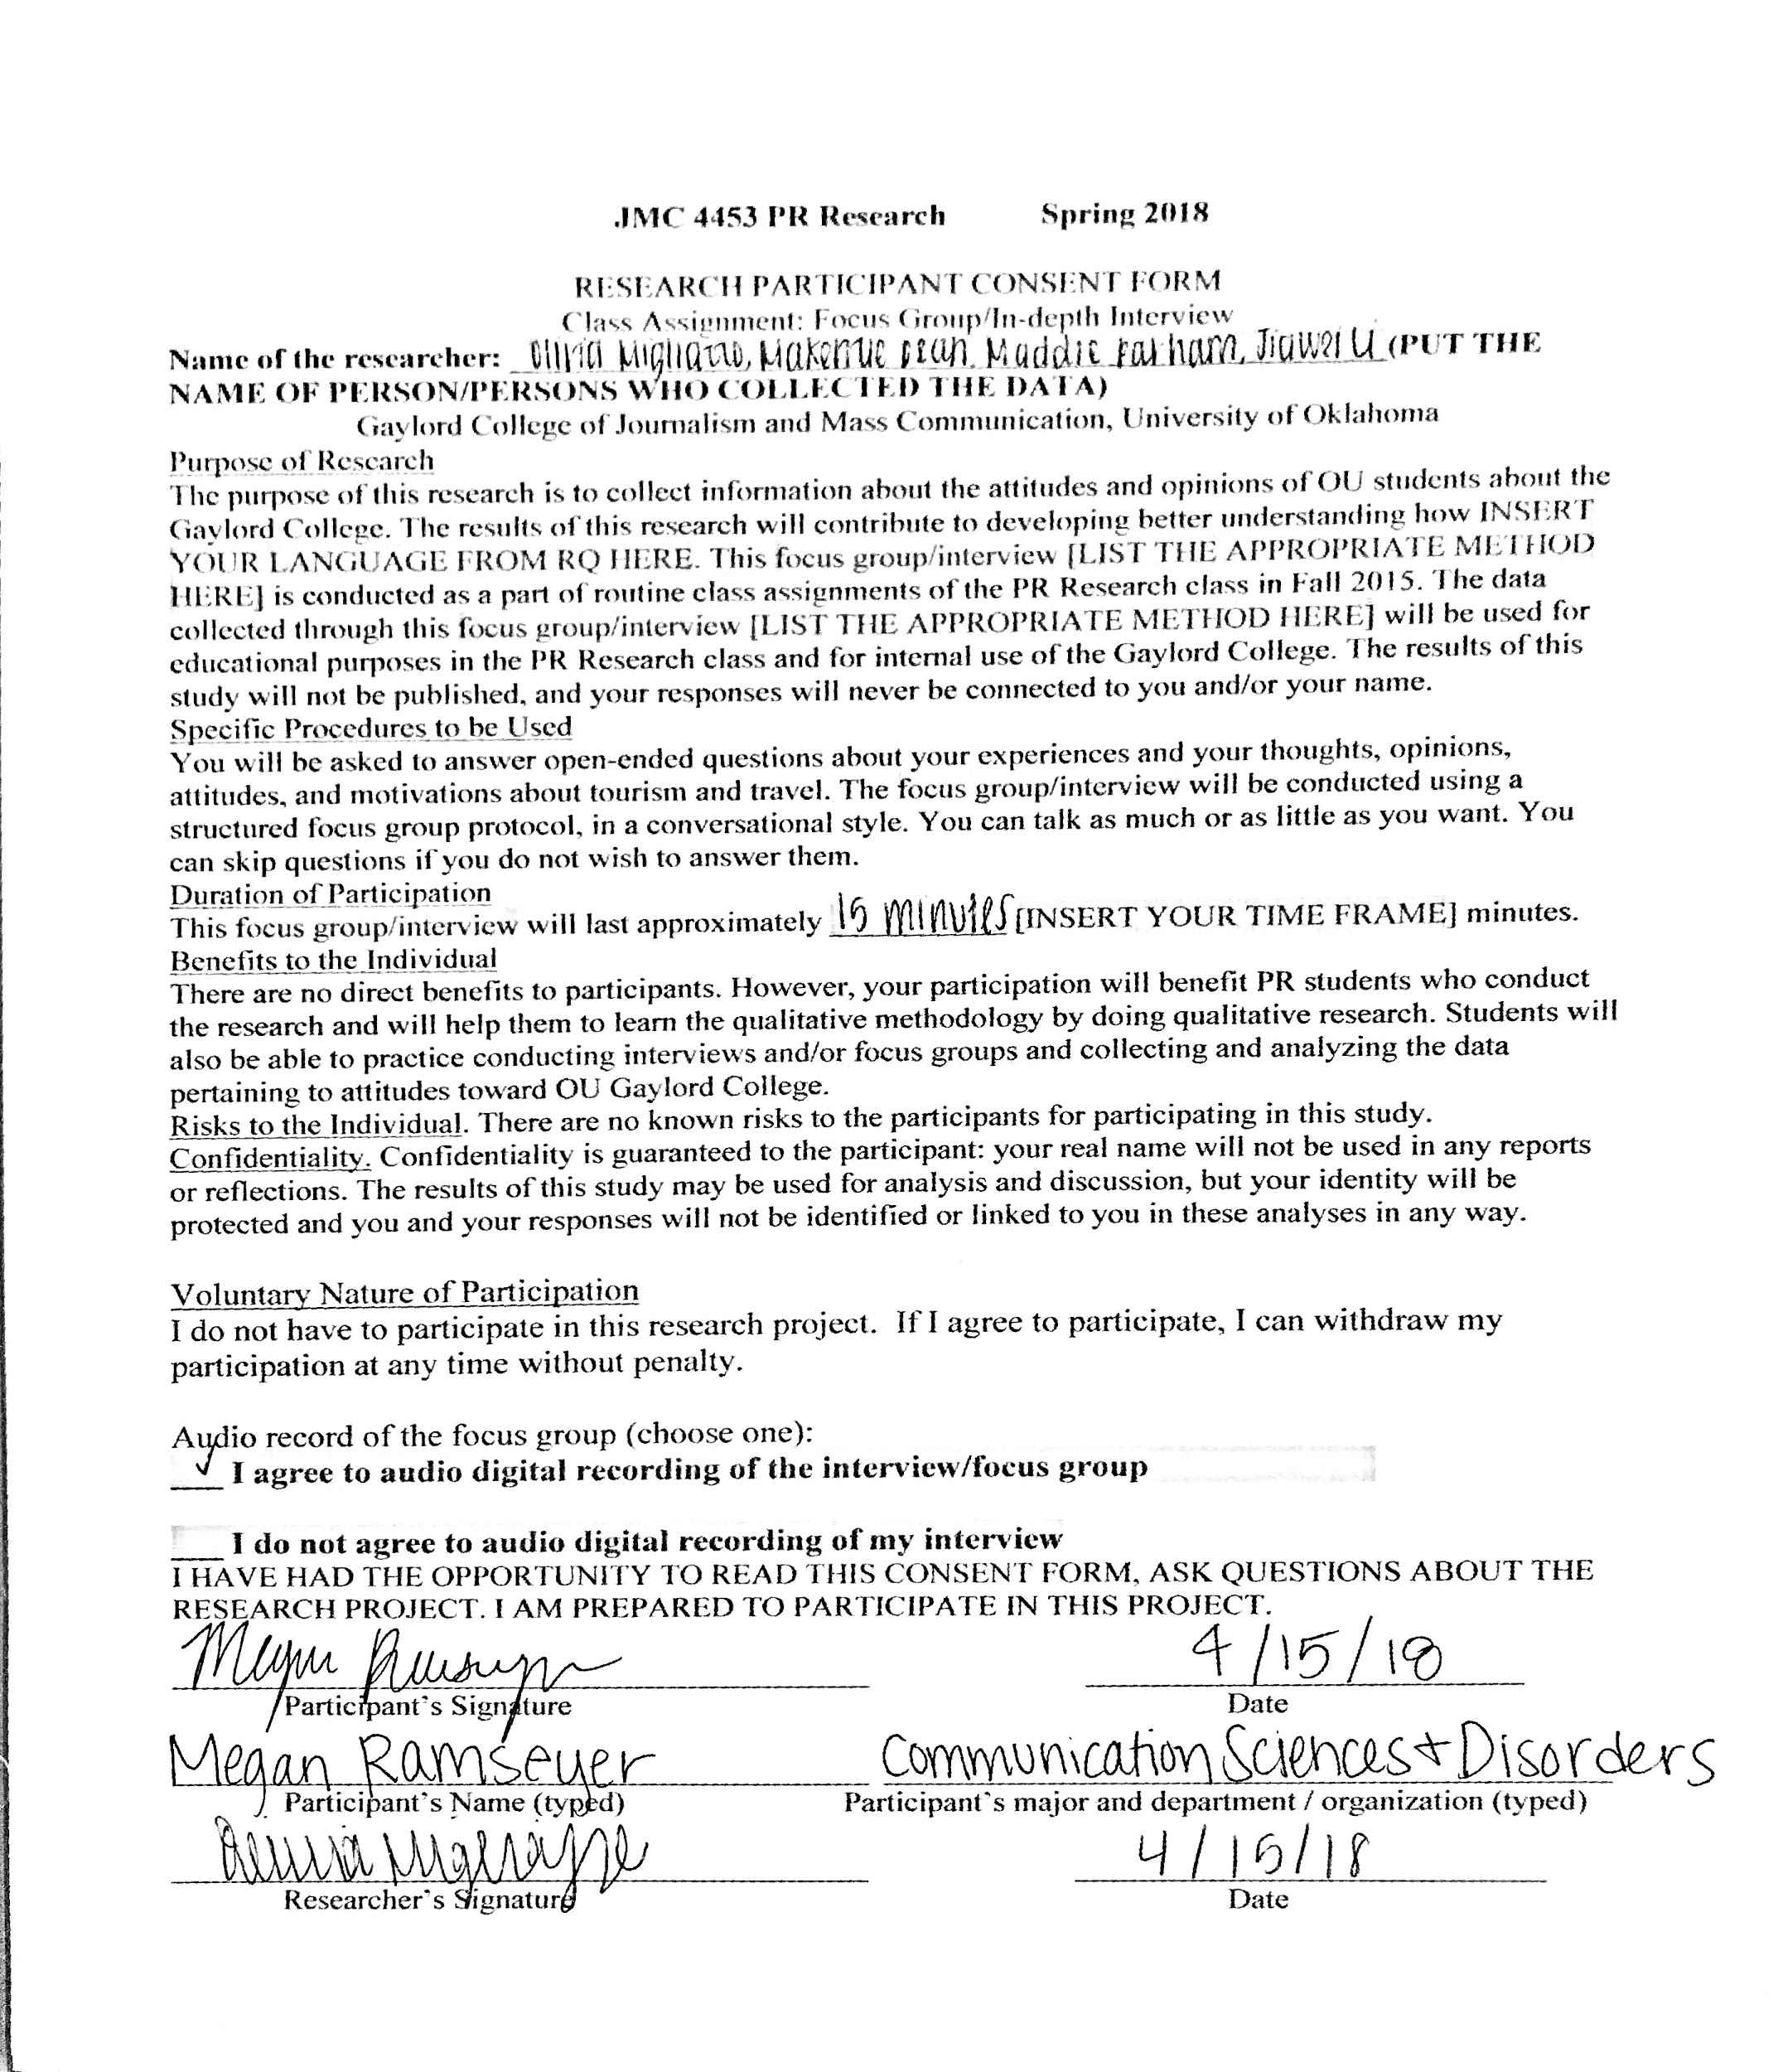
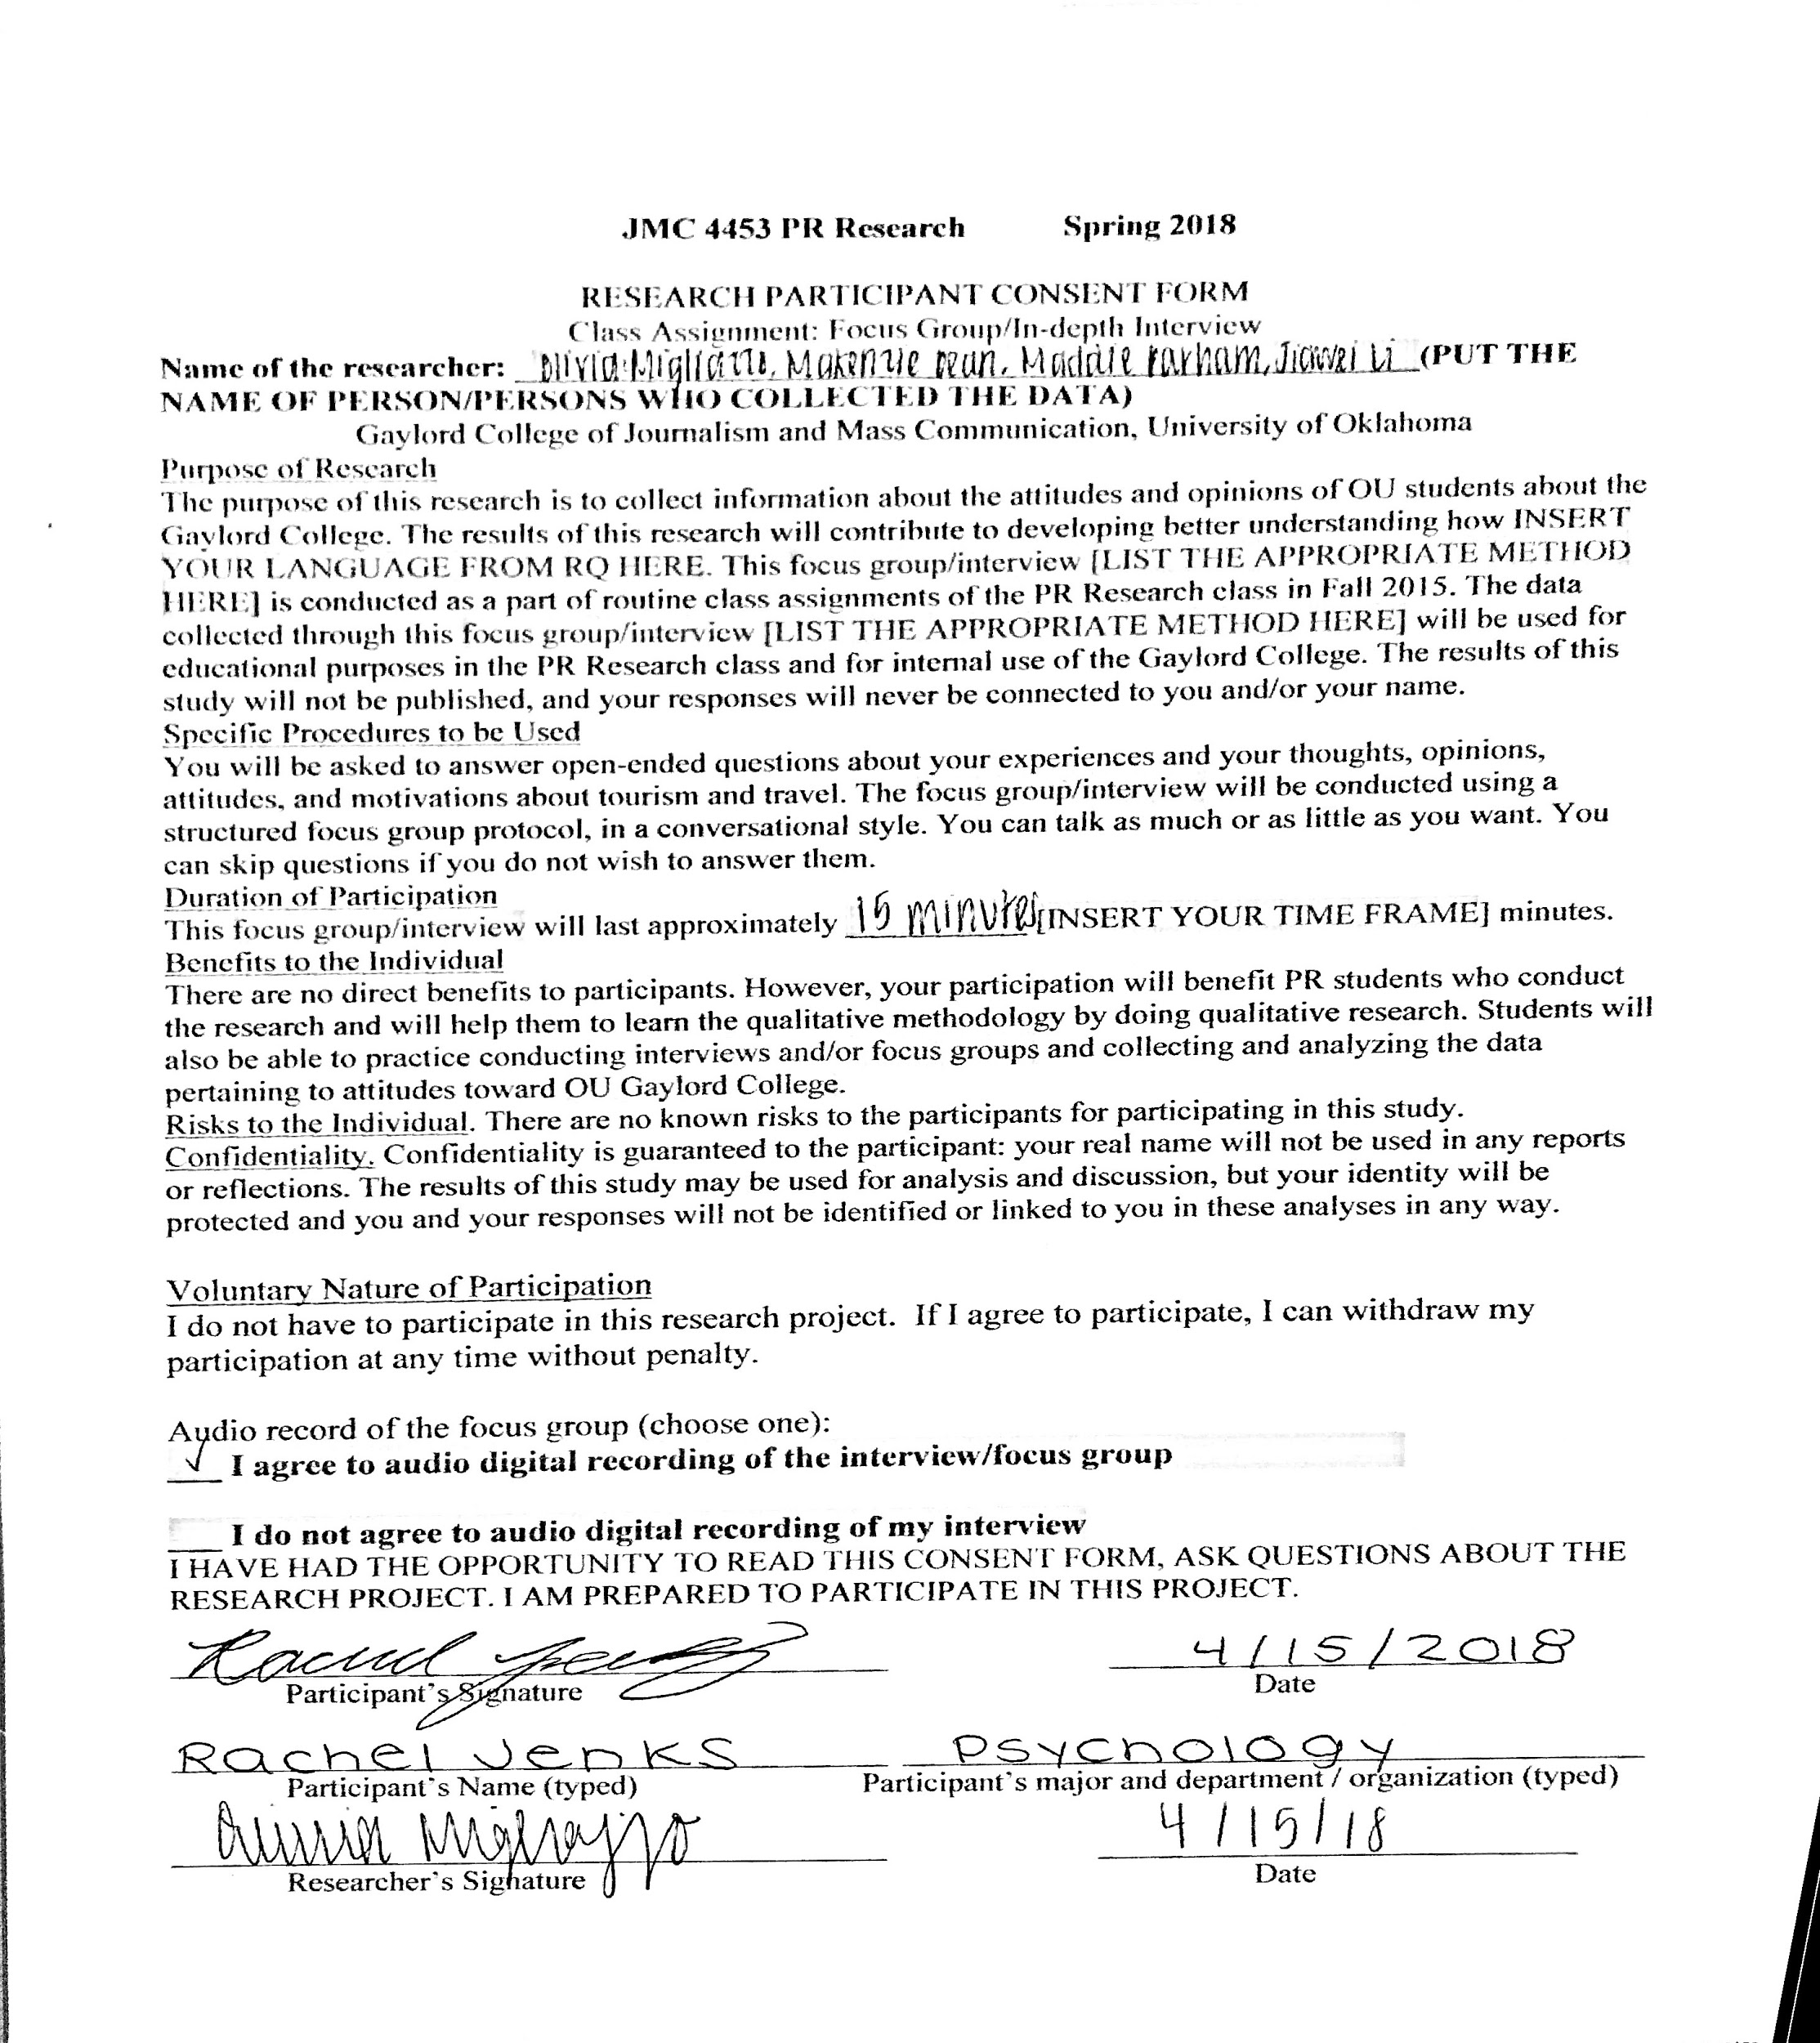
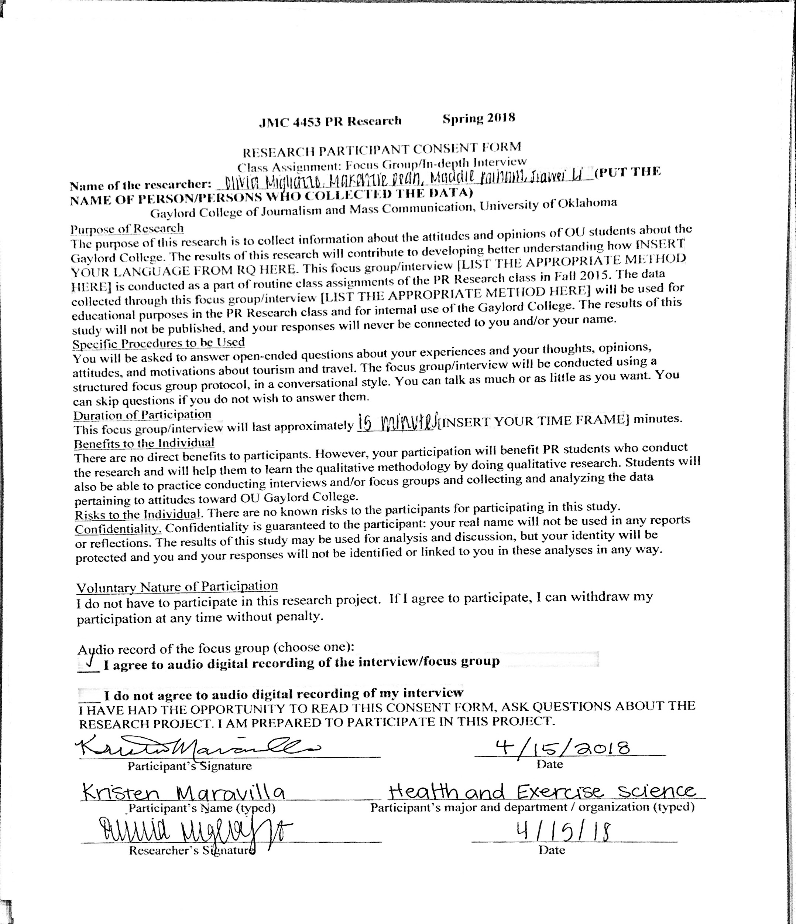
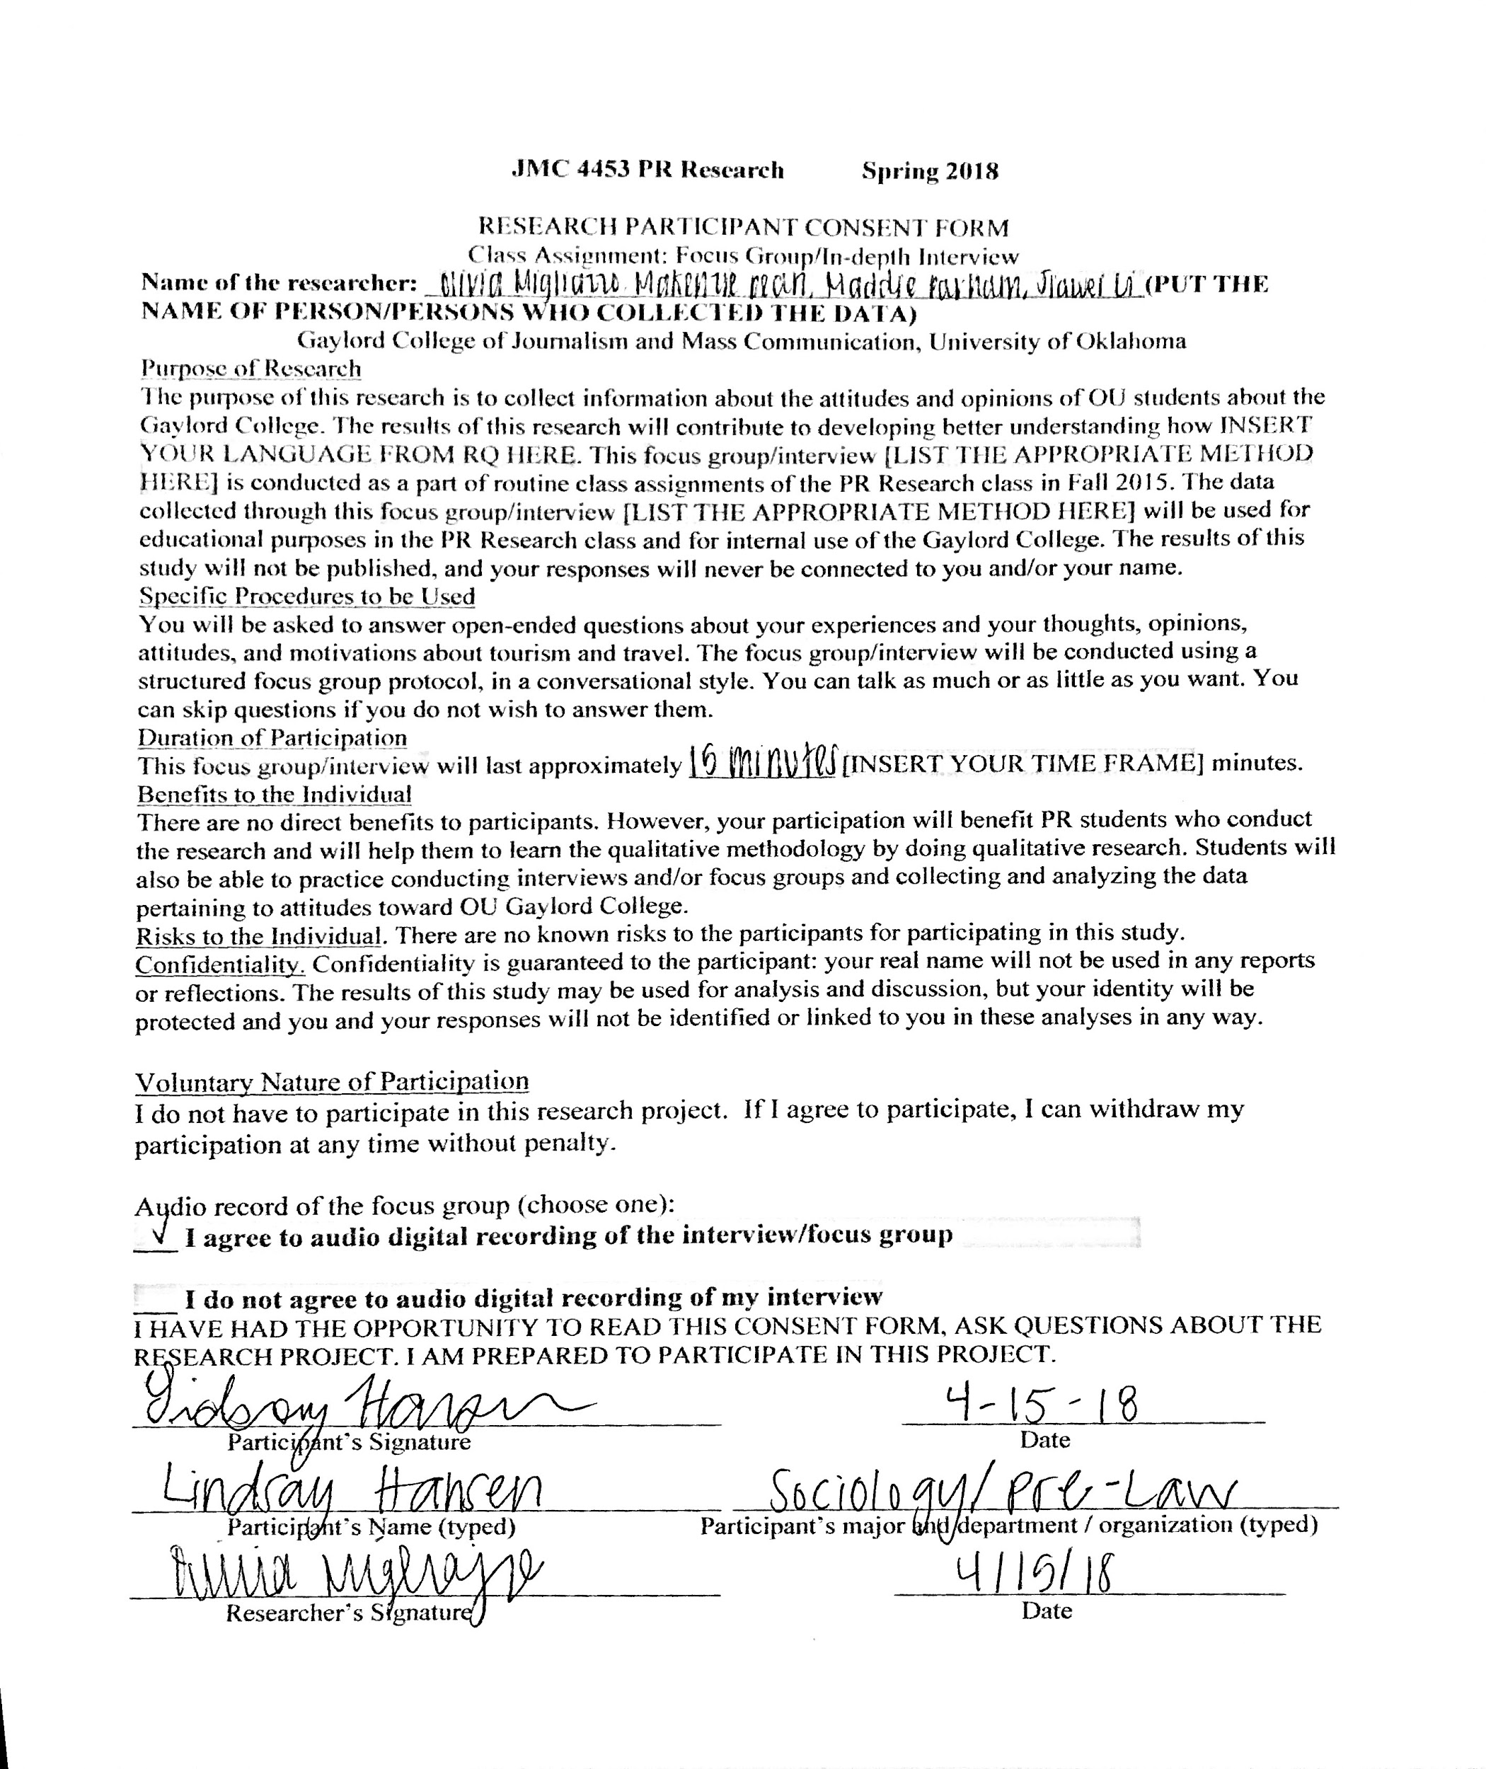
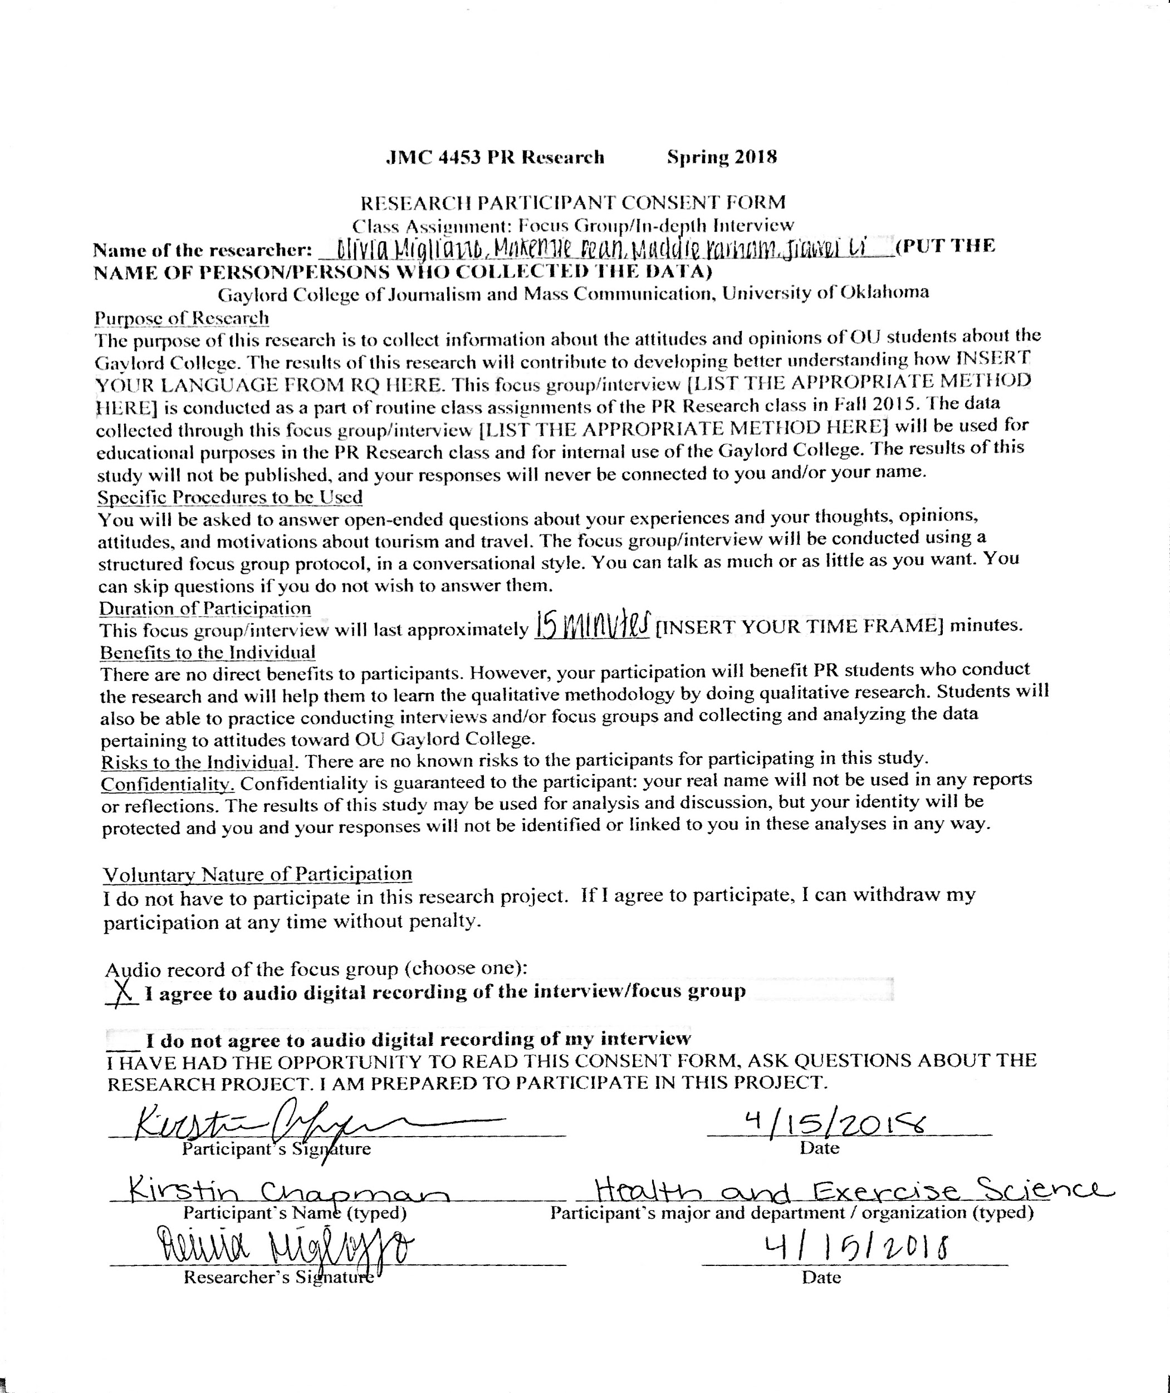
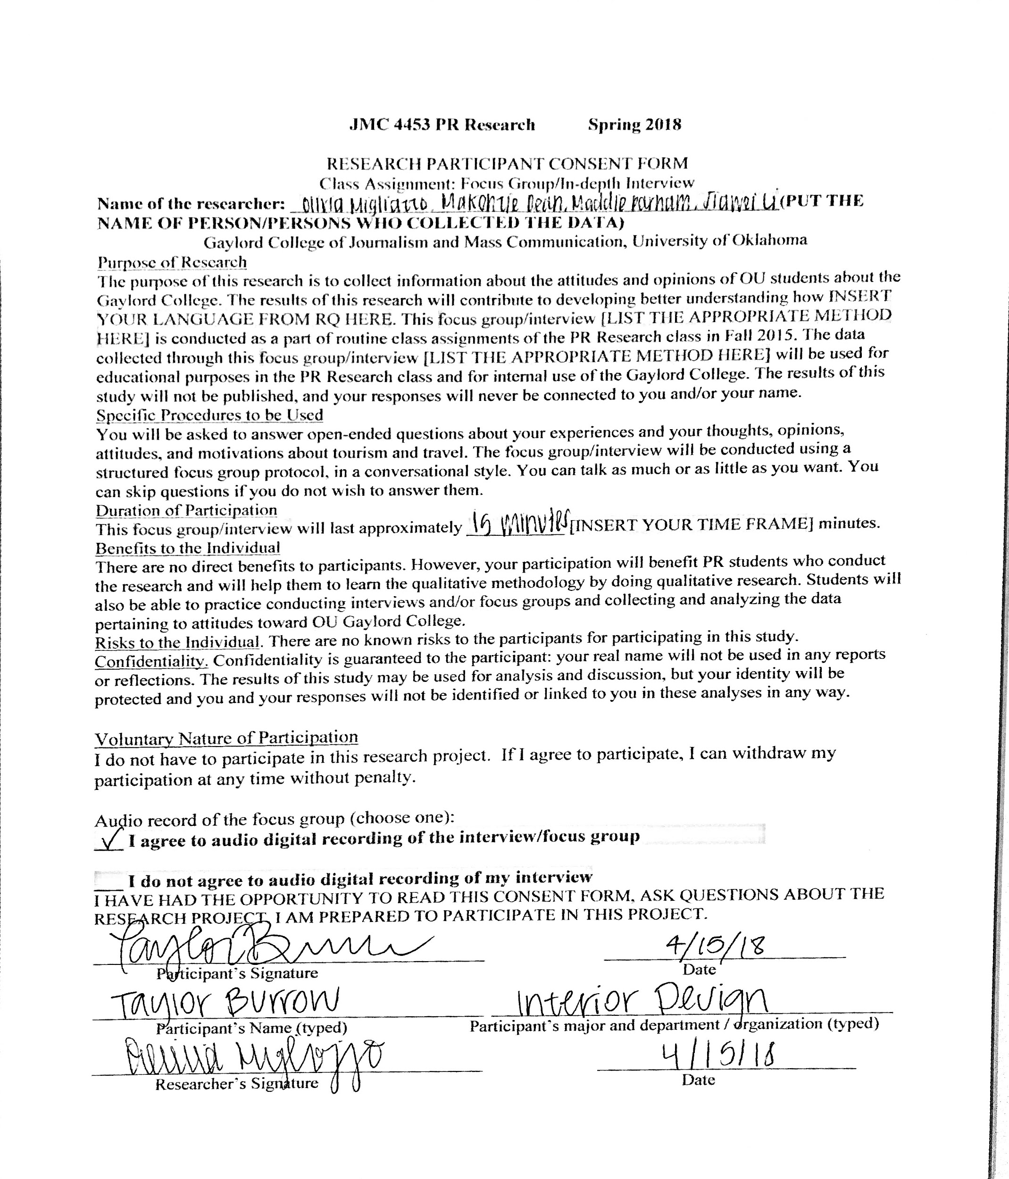
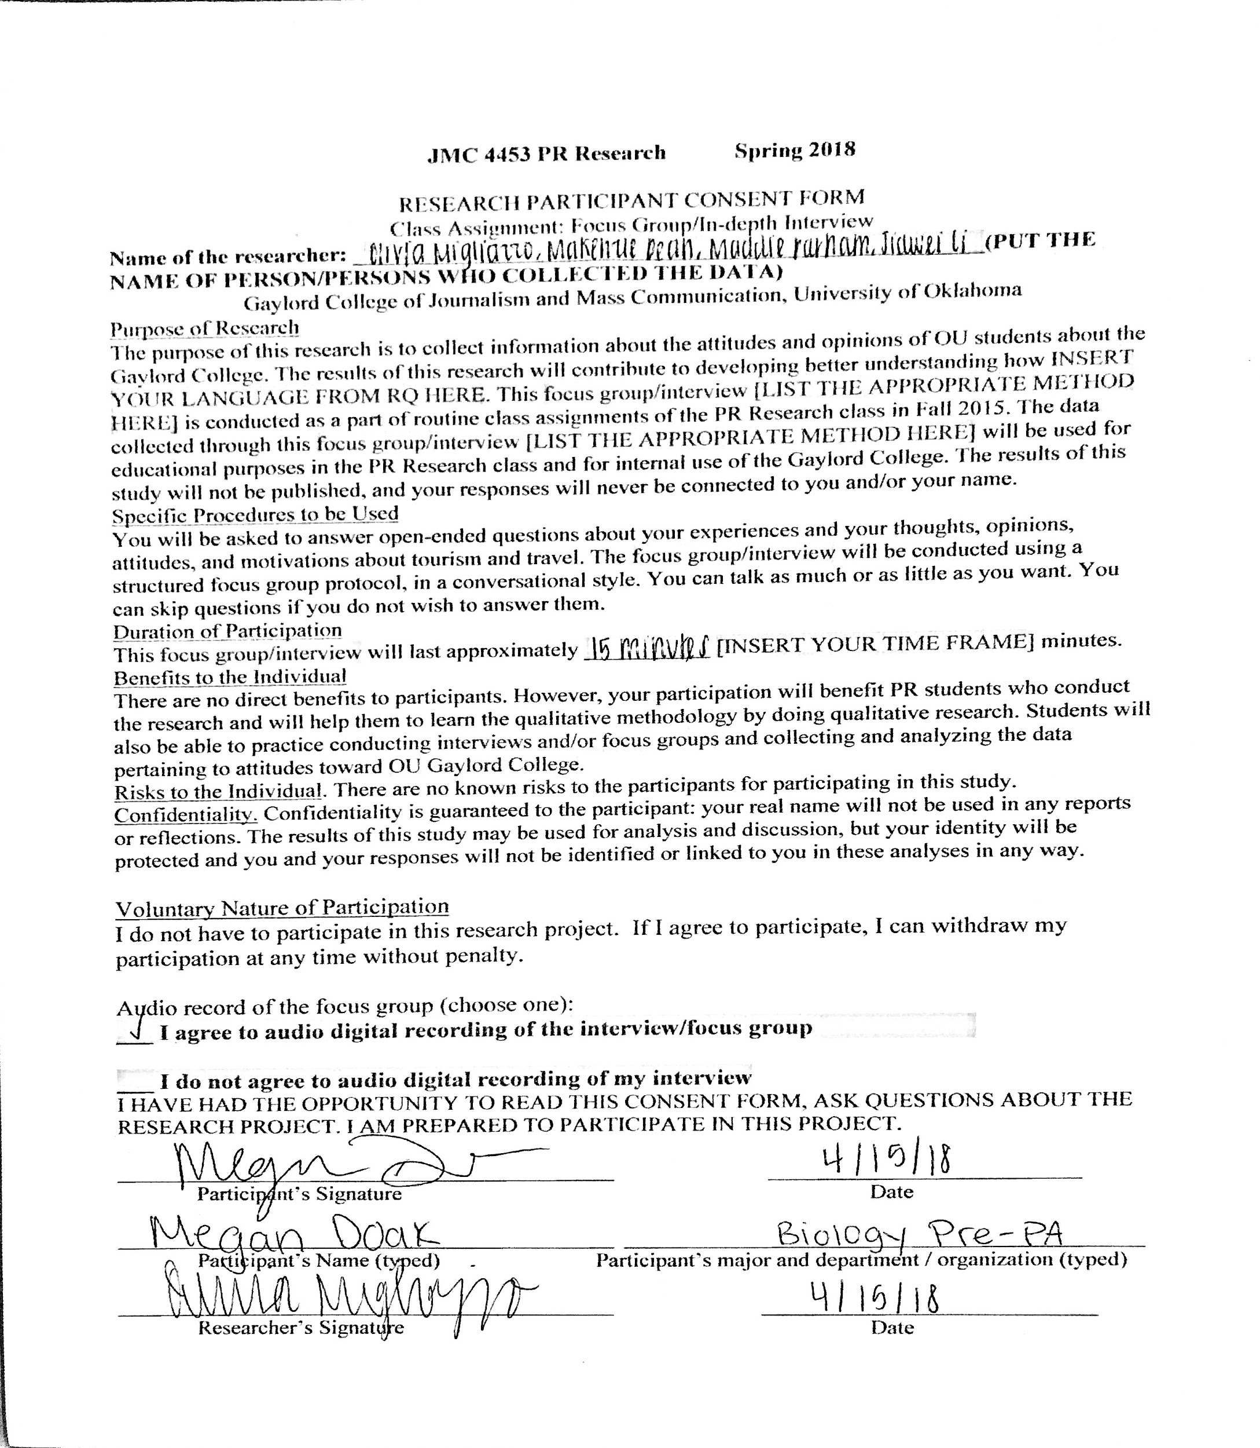
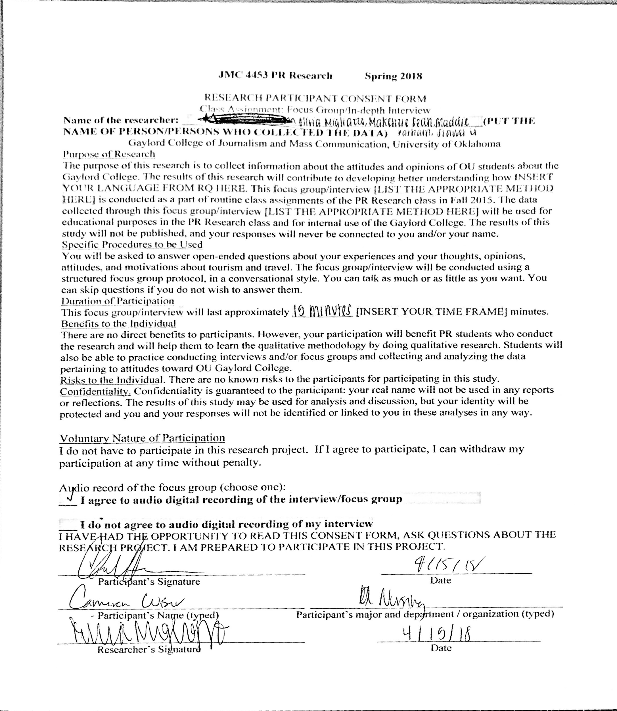

Appendix 7: Survey Results

